Windows 2000 Professional installation via Microsoft Remote Installation Services (RIS) fails on notebook computers using 3Com 3CCFE575CT, 3Com 3CXFE575CT, Dell 3CCFE575CT-D PCCARD NICs, and 3Com MBA on Disk.

This information applies to:
Undocked notebook computers using 3Com 3CCFE575CT, 3Com 3CXFE575CT, Dell 3CCFE575CT-D PC CARD NICs, and 3Com Managed PC Boot Agent (MBA) on Disk.

Symptons:
When trying to install Windows 2000 Professional with a notebook and one of the PC CARDS (listed above), using a Pre-boot Execution Environment (PXE) client from a Remote Installation Service (RIS) server, the installation fails and blue screens. The notebook attaches to the network through the PXE portion of the setup. However, once the text mode setup reaches the “Starting Windows 2000” segment (after loading all the default drivers into memory), it blue-screens.

Workaround:
The workaround involves using the 3Com RIS Menu Editor to create a new menu item under the Client Installation Wizard. This will provide an alternative network boot image to the default image used to launch a Windows 2000 Professional installation. The alternative uses a RAMDRIVE to initiate the installation of Windows 2000 Professional from a shared copy of the CD on the network.

To resolve this problem, copy the Microsoft Windows 2000 Professional CD to the RIS server and share the directory. Create a Network Client Boot disk. Modify the Network Client Boot disk so that it will use the 3Com Universal NDIS driver and boot to your Windows 2000 RIS server share directory. Copy DOS files to the Network Client Boot disk. In the batch files, insert commands to create a RAMDRIVE to store the DOS, and other files in RAM. You will need to use PKZIP in order to fit all the files on a diskette. Using 3Com RIS Menu Editor, create an image of the Network Client Boot disk.

Items you will need:
      - 3Com RIS Menu Editor http://www.lanworks.com/downloads/

      - 3Com BPPATCH.EXE - is a utility located on the 3Com EtherCD CD. A text file, BPPATCH.TXT, that explains its use, is also available on the EtherCD.

      - 3Com’s Universal NDIS driver (UNDIS3C.DOS) is an MBA utilty found on the 3Com EtherCD. Refer to the MBA User Guide for a description of its use.

      - Microsoft Windows 2000 server with RIS installed

      - Microsoft Windows NT 4.0 with Network Client Administrator configured.

      - RAMDRIVE.SYS (for more info on RAMDRIVE visit http://www3.sympatico.ca/rhwatson/dos7/v-ramdrive-sys.html

      - PKUNZIP, and PKZIP

      - Microsoft Windows 2000 Professional CD

- Copy the Windows 2000 Professional CD to the Windows 2000 Server and share the directory.
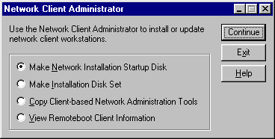
- Create a Network Installation Startup Disk, using the MS Windows NT 4.0 Network Client Administrator.
- Edit the protocol.ini and system.ini file on the diskette that was just created so that it will use the 3Com Universal NDIS driver, UNDIS3C.DOS. (See Sample Files at the end of this document). Test the diskette and make sure it is able to connect to the share that was created on the Windows 2000 Server earlier on.
- Still in the system.ini file, change any reference to the A:\drive to point to the RAMdrive.
- Using PKZIP, zip the NET directory. Name the ZIP file NET.ZIP
- Using RIS Menu Editor, create a DOS boot image and label it WIN2K Add to this disk smartdrv.exe, pkzip.exe, pkunzip.exe, lastdrv.com, ifshlp.sys, himem.sys, freemem.com, format.com, fdisk.exe, fdisk.asc, bppatch.exe, ramdrive.sys, and emm386.exe.
- Pkunzip is used to uncompress files to the ramdrive. Format and fdisk are used to fdisk and format the destination hard drive. The BPPATCH utility allows you to update any text file contained in a boot image file with information from DHCP/BOOTP reply packets. In this example, BPPATCH is used to automatically populate the computer name in the system.ini file. The image will use the NIC’s MAC address for the computer name in the system.ini file. RAMdrive is used to create a virtual disk in memory to store DOS and NET directories.
- Add the NET.ZIP file to this DOS boot disk.
- Copy the config.sys and the autoexec.bat file from the Network Client Administrator diskette to the WIN2K diskette. (See the sample files at the end of this document).
- Edit the config.sys file to load the ramdrive.sys device. Edit the autoexec.bat to copy the DOS files and the files in the NET directory to the RAMDRIVE.
- Create the Windows 2000 Professional boot image using the RIS Menu Editor and the DOS boot disk you created earlier. 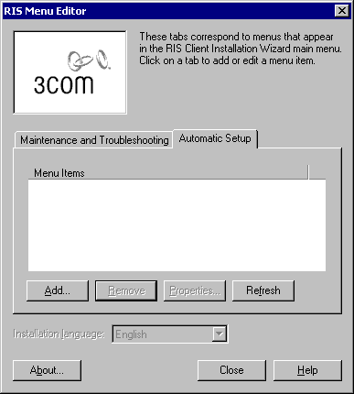
- Make sure you select “Keep UNDI in memory” and “Keep Base Code in memory”.
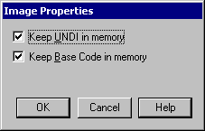

The notebook client is now ready to use the alternative network boot image.

Sample Autoexec.bat

@echo off
path=a:\dos
lastdrv
REM setenv.bat is built by BPPATCH
bppatch /s >setenv.bat
call setenv.bat
MD D:\NET
MD D:\DOS
COPY A:\*.* D:\*.* >NUL
COPY A:\DOS\*.* D:\DOS\*.* >NUL
pkunzip A:\DOS\net.zip D:\NET >NUL
BPPATCH D:\NET\SYSTEM.INI
D:
SET COMSPEC=D:\COMMAND.COM
PATH=D:\DOS;D:\NET;
D:\DOS\FORMAT C: /S /Q /V:WIN2KPRO

D:\net\net initialize
D:\net\netbind.com
D:\net\tcptsr.exe
D:\net\tinyrfc.exe
D:\net\nmtsr.exe
D:\net\emsbfr.exe
@echo Connecting to boot server...
net logon administrator grep /savepw:no /y
net use z: \\inspriron\win2kpro

SMARTDRV.EXE
z:
winnt.exe /s:z:\ /t:c: /u:z:\unattend.txt

:END
pboot /reboot

Sample Config.sys

files=60
device=A:\DOS\ifshlp.sys
lastdrive=z
DEVICE=A:\DOS\HIMEM.SYS /testmem:off
DEVICE=A:\DOS\RAMDRIVE.SYS 3072 /E
DEVICE=A:\DOS\EMM386.EXE NOEMS
DOS=HIGH,UMB

Sample Protocol.ini
[network.setup]
version=0x3110
netcard=ms$UNDIS3C,1,MS$UNDIS3C,1
transport=tcpip,TCPIP
lana0=ms$elnk3,1,tcpip

[ms$UNDIS3C]
DRIVERNAME=UNDIS3C$

[protman]
drivername=PROTMAN$
PRIORITY=MS$NDISHLP

[tcpip]
NBSessions=6
DefaultGateway0=
SubNetMask0=
IPAddress0=
DisableDHCP=0
DriverName=TCPIP$
BINDINGS=ms$UNDIS3C
LANABASE=0

Sample System.ini

[network]
filesharing=no
printsharing=no
autologon=no
computername=#@cha############
lanroot=D:\NET
username=Administrator
workgroup=LANWORKS
reconnect=no
dospophotkey=N
lmlogon=0
logondomain=WINNT40
preferredredir=basic
autostart=basic
maxconnections=8

[network drivers]
netcard=undiS3c.dos
transport=tcpdrv.dos,nemm.dos
devdir=D:\NET
LoadRMDrivers=yes

[Password Lists]
*Shares=D:\net\Share000.PWL

