Survival Fishing
A few methods for survival fishing
There are any number of ways to fish but when you are in a survival situation you wont have the luxury of sitting on the river bank all day with a pole in your hands. These are a few suggestions that might help in the coming times.
Traps:
There are several trap designs that work. I am sure you will be able to construct one that will work for you.
Take some "chicken wire" and form a tube about 16 inches in diameter. You can make it square, if you want, but a tube is easier. Using wire or such, you will need to sew the seam of the tube. Also sew one end shut in such a way that you can open fairly easy. Then cut a "mouth" out of a square of the chicken wire. You will need to form a cone that fits into the other end of the "tube". The smaller end points into the tube. The smaller end should be small enough to allow fish to swim through but not big enough to let them swim back out. This kind of trap needs to have bait put inside to attract the fish. If you can find a small creek that fish usually swim up, place the trap with the mouth facing downstream and block access of the rest of the creek so that all fish will have to swim into the trap.
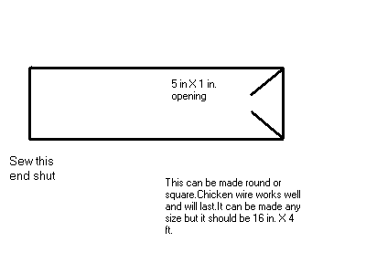
You can make the trap out of anything. The Indians used to make them out of sticks. The fish can be left in the trap if there are too many for you to eat at one time. This way you could have fresh fish anytime that you needed them. You can leave them in the trap for a week or so. Much longer than that and the fish would starve.
Bait:
Using bait makes finding fish easier. If you are near a stream, river, or lake, you can keep a "supply" of fish nearby by baiting them. You can place a trap at the bait or fish with hook and line. In running water place the bait in a certain place by weighting it down so it wont drift off. The fish will gather on the downstream side of the bait to get the particles as they float by.
I have taken canned dog food, poked holes in the can then throw it in the water. You can also take "hog feed" and place it in a drum , add water, then cook it down to a thick paste. Place a ball of the cooked feed in a croaker sack or any material with a large weave then place that in the water. There are any number of recipes for "bait".
Needless to say, be careful while contemplating or practicing these skills. It is illegal to bait fish in most places and traps have to be "registered" and a trap license obtained. After TSHTF, it wont matter but before then you will need to observe all laws.

