Curriculum Vitae
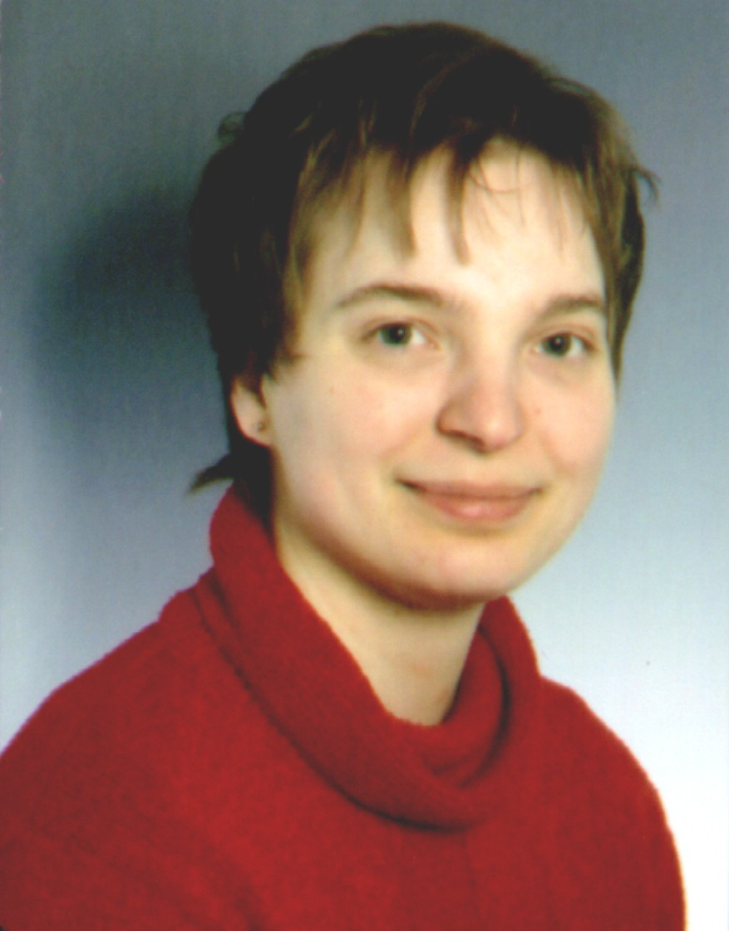
Name: Silke-Katrin Kunze

Marital status: Single

Date of birth: April 29, 1978

Place of birth: Radebeul, Saxony

Religion: Protestant

Current address: c/o Christian German School Chiangmai
P. O. Box 12 (Saraphi)
Chiang Mai 50140, Thailand
00 66 - 53 43 71 99 / 00 66 - 08 40 47 59 90 (mobile phone)
Ms_Katie@web.de / Mrs_Kay@gmx.net
Skype: phoon_naphaa (Thai name for “blessing from the sky”)

Parents: 1. Father: Dr. Volkmar Kunze, born 1954, Mayor
2. Mother: Kerstin Kunze, born 1960, Housewife

Siblings: 2 Brothers: Christian, born 1975, & Johannes, born 1981
2 Sisters: Regina, born 1985, & Angelika, born 1989

Education:

1984 Starting school
1984 - 1996 General school education
1996 School leaving exam at the Lößnitzgymnasium Radebeul
Overall mark: 2.5

Particularities:

1994 - 1996 Student exchange: two weeks in the French part of Switzerland
09/02 - 07/22/1997 In Tombstone & Tucson, AZ, USA

Studies:

WS 1997 / 1998 - SS 1999 Basic studies English / French teacher’s degree GY
09/20/1999 - 12/20/1999 In Arras, France
01/20/2000 - 05/16/2000 In Arizona, USA (GLC 6 Project)
WS 2000 / 2001 - SS 2002 Main studies E / F teacher’s degree GY
WS 2002 / 2003 - SS 2003 Exam period (E & PPA; F & Pedagogy / Psychology)
Overall mark: 2.6

Particularities:

SS 1998 - SS 1999 & WS 2000 / 2001 - WS 2002 / 2003
Student assistant to Prof. Dr. Barbara Marx (Italian cultural history)
SS 2002 - WS 2002 / 2003
Student assistant to Prof. Maria Lieber (French linguistics)
July 2000 - September 2003
Member of the Red Cross catastrophe prevention unit Radebeul

Teacher's training:

11/01/2003 - 10/31/2005 At the Studienseminar Bensheim, Hesse
until 09/30/2005 At the Geschwister-Scholl-Schule, Bensheim
11/19/2003 - 03/17/2004 „Intel® Teaching for the future“
03/13 & 11/16/2004; 06/11/2005 Advanced French training
05/28/2004 - 01/22/2005 „Fancy theater“
06/09/2004 - 07/14/2004 „DGSS-Stimm-Werkstatt 2004“
07/24/2004 - 08/22/2004 In Rivière, France
10/06/2004 - 04/14/2005 4 times Klippert training ^{(methodical competence)}
2004 - 2006 „Youth debates“

Employment:

10/04/2005 - 07/14/2006 At the Starkenburg-Gymnasium Heppenheim, Hesse
24 hours per week (lower grade & junior high school)
03/15/2006 „Learning today - The importance of movement…“
05/22/2006 „Sportstacking: encouragement for body and spirit“
08/21/2006 - 06/26/2008 At the Christian German School, Chiang M., Thailand
First year: 24 hours per week (lower grade & junior
high school including exams grades 9 & 10)
Second year: 28 hours per week (lower grade &
junior high school including exams grades 9 & 10)
02/15/2007 „Differentiation in the classroom“

Place and Date: Chiang Mai, April 08, 2007
Signature: Silke-Katrin Kunze

