TABLA DE VERDAD
Dec | Hex | D | C | B | A | a | b | c | d | e | f | g | Display
0 | 0 | 0 | 0 | 0 | 0 | 1 | 1 | 1 | 1 | 1 | 1 | 0 | 0
1 | 1 | 0 | 0 | 0 | 1 | 0 | 1 | 1 | 0 | 0 | 0 | 0 | 1
2 | 2 | 0 | 0 | 1 | 0 | 1 | 1 | 0 | 1 | 1 | 0 | 1 | 2
3 | 3 | 0 | 0 | 1 | 1 | 1 | 1 | 1 | 1 | 0 | 0 | 1 | 3
4 | 4 | 0 | 1 | 0 | 0 | 0 | 1 | 1 | 0 | 0 | 1 | 1 | 4
5 | 5 | 0 | 1 | 0 | 1 | 1 | 0 | 1 | 1 | 0 | 1 | 1 | 5
6 | 6 | 0 | 1 | 1 | 0 | 1 | 0 | 1 | 1 | 1 | 1 | 1 | 6
7 | 7 | 0 | 1 | 1 | 1 | 1 | 1 | 1 | 0 | 0 | 0 | 0 | 7
8 | 8 | 1 | 0 | 0 | 0 | 1 | 1 | 1 | 1 | 1 | 1 | 1 | 8
9 | 9 | 1 | 0 | 0 | 1 | 1 | 1 | 1 | 1 | 0 | 1 | 1 | 9
10 | A | 1 | 0 | 1 | 0 | X | X | X | X | X | X | X | -
11 | B | 1 | 0 | 1 | 1 | X | X | X | X | X | X | X | -
12 | C | 1 | 1 | 0 | 0 | X | X | X | X | X | X | X | -
13 | D | 1 | 1 | 0 | 1 | X | X | X | X | X | X | X | -
14 | E | 1 | 1 | 1 | 0 | X | X | X | X | X | X | X | -
15 | F | 1 | 1 | 1 | 1 | X | X | X | X | X | X | X | -

ECUACIONES CANONICAS Y DESARROLLO DE MAPAS DE KARNAUGH

$$a_{(\text{BCDA})}=Σ_{4}(0,2,3,5,6,7,8,9)+Σ_{4}(\text{10},\text{11},\text{12},\text{13},\text{14},\text{15})$$
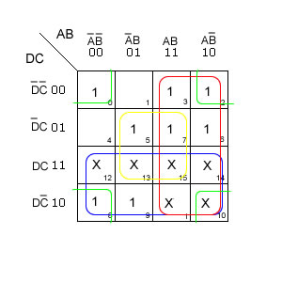 | 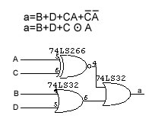

$$b_{(\text{BCDA})}=Σ_{4}(0,1,2,3,4,7,8,9)+Σ_{4}(\text{10},\text{11},\text{12},\text{13},\text{14},\text{15})$$
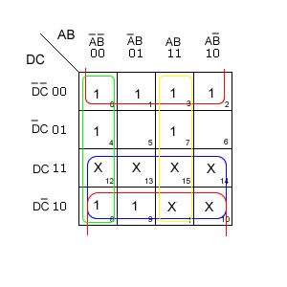 | 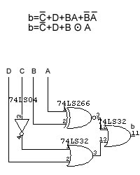

$$c_{(\text{BCDA})}=Σ_{4}(0,1,3,4,5,6,7,8,9)+Σ_{4}(\text{10},\text{11},\text{12},\text{13},\text{14},\text{15})$$
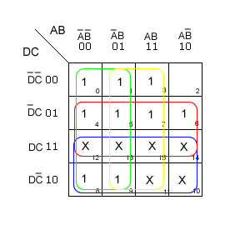 | 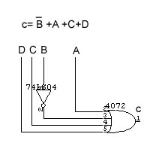

$$d_{(\text{BCDA})}=Σ_{4}(0,2,3,5,6,8,9)+Σ_{4}(\text{10},\text{11},\text{12},\text{13},\text{14},\text{15})$$
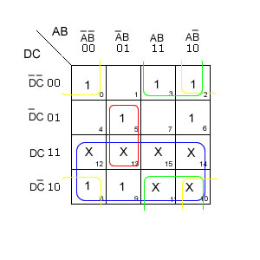 | 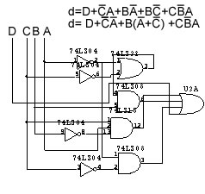
$$e_{(\text{BCDA})}=Σ_{4}(0,2,6,8)+Σ_{4}(\text{10},\text{11},\text{12},\text{13},\text{14},\text{15})$$
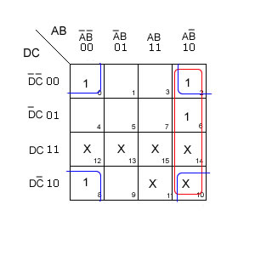 | 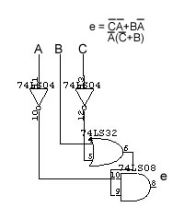

$$f_{(\text{BCDA})}=Σ_{4}(0,4,5,6,8,9)+Σ_{4}(\text{10},\text{11},\text{12},\text{13},\text{14},\text{15})$$
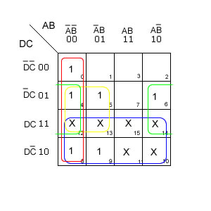 | 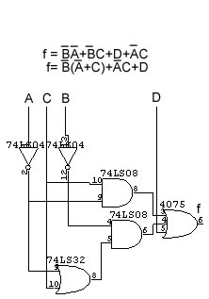

$$g_{(\text{BCDA})}=Σ_{4}(2,3,4,5,6,8,9)+Σ_{4}(\text{10},\text{11},\text{12},\text{13},\text{14},\text{15})$$
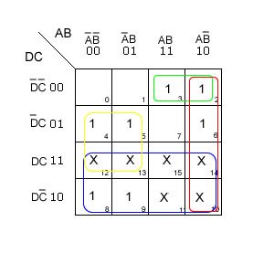 | 