Chapter 1: Looking at the Earth Open Response

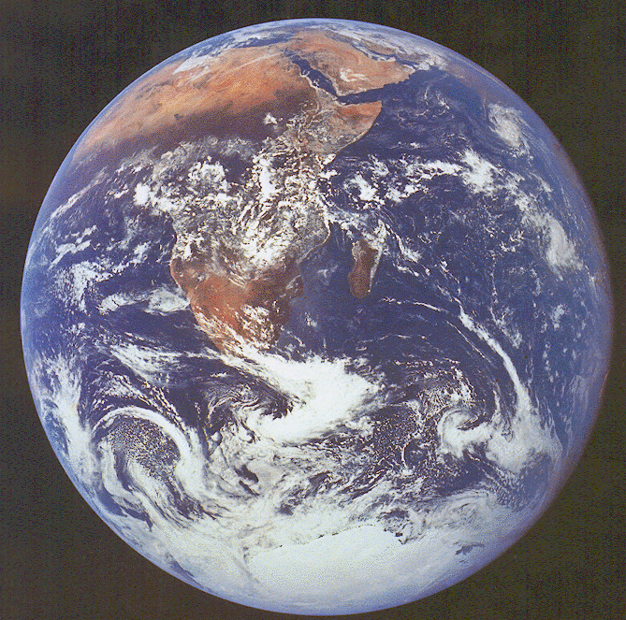

Directions: Complete the following Open Response question concerning Chapter 1: Looking at our Earth. Be sure to include a graphic organizer (4 Column method, Webbing, Outline, etc.) with your response.

Our planet Earth is one of a group of planets that revolve around the sun. The sun and revolving of the Earth are very pivotal in life on Earth. Our seasons change and we have days and nights.

- Construct a diagram illustrating what causes us to have day and night.

- Discuss and Explain your illustration of what causes day and night on Earth.

- Compare the causing of Day and Night with why the seasons change on Earth.

