Research Project

Date: August 27th, 2003

You are about to journey into remote rain forests, bleak deserts, bustling marketplaces, and mountainous villages. You are entering the world of GEOGRAPHY – the study of earth and its people. Imagine that you could visit any continent in the world. 6th grade Geography allows you to visit all continents.

Assignment:

You will be divided into 7 groups. Each group will be given a particular place on different continents. I will give each of you a place on one of the seven continents of the world. Your job as a group is to research the place you are given and find out some of the following information:
- Physical features (mountains, rivers, etc.)
- Climate
- Major resources
- Government
- Economy
- Animals and Plant Life
- Recreation

Each group must find one TOURIST ATTRACTION, MAJOR LANDMARK, or HISTORICAL EVENT and explain why it is significant for your place. For Example: Stonehenge – Stonehenge is in England.

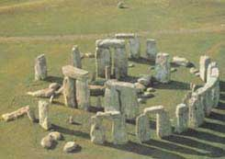 ← Stonehenge

You need to choose 4 of the topics above to research about your place. Once you have researched your topic you need to create one of the following:

- Create a Visual Representation
- Collage
- Brochure
- Power Point Presentation
- Create an Art Mask or Celebration costume from that continent
- Recreate a Musical instrument from that continent
- Construct a Picture book
- Rewrite the lyrics to one of your favorite songs about your place
- Perform a News broadcast about your continent.
- Prepare a famous dish from that continent

** It is required that each group orally presents their continent to the rest of the class.

