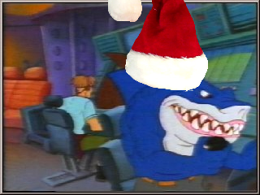

1. Name (circle one): Brandon Not Brandon

2. Handle: _________________________

3. Are you opposed to Bonus Pretzels? Yes Hellz No lol

4. OS (circle one): Windows XP* *non XP need not apply

5. Do you have a problem with Dracula coming over tonight? N N

