DAVIS EXTRA

Our final week went by so quick! We had a crazy week cleaning up and preparing for the summer. We had a very hot one, so we took it easy. We kept the lights off and water on our desks. The end of the year party was huge success! We had a blast! Thank you to all of the moms who helped out! Thank you, Mrs. Villarino for pulling it together so last minute! We kept playing math around the world. Again, I have to say they just love this game. We worked hard on adding and subtracting this week. They all can successfully add with carrying. The only problem, they want to carry every problem. This will slowly decrease as they progress. This is a common problem that most children have when first introduced to carrying. The children just think it is so cool to carry and want to do it with every problem! We have been reading through the stories in our final book. Finally, the book had the length and type of stories that the children were able to read! A few of the stories had incredible pictures and were very interesting. Too bad I didn’t send them home for you all to see. Remember to keep reading over the summer! This will continue their success for next year. In the children’s gift I am putting a cd-rom called Ready for School 1st grade. This is a really fun game, which will reinforce all the skills that were learned during first grade, both math and reading.
I am extremely excited for a relaxing summer, as I am sure you are! One problem though, I will truly miss every one of the children. And the parents I saw every day. This time at school 21 has been the greatest experience of my life. My one regret, is that I didn’t get the opportunity to spend the entire year with your children. I don’t think that any class in the past or in the future will make such an impact that this class has! Thank you so much for this amazing experience, I will never forget you!
Make sure to check my website over the summer. I plan on adding to it for you. I will be putting on website links and such to help over the summer. Also, you will be able to email me through it. I would love to here from the children over the summer and you as well!
Take care and have a wonderful summer!

STAR STUDENT

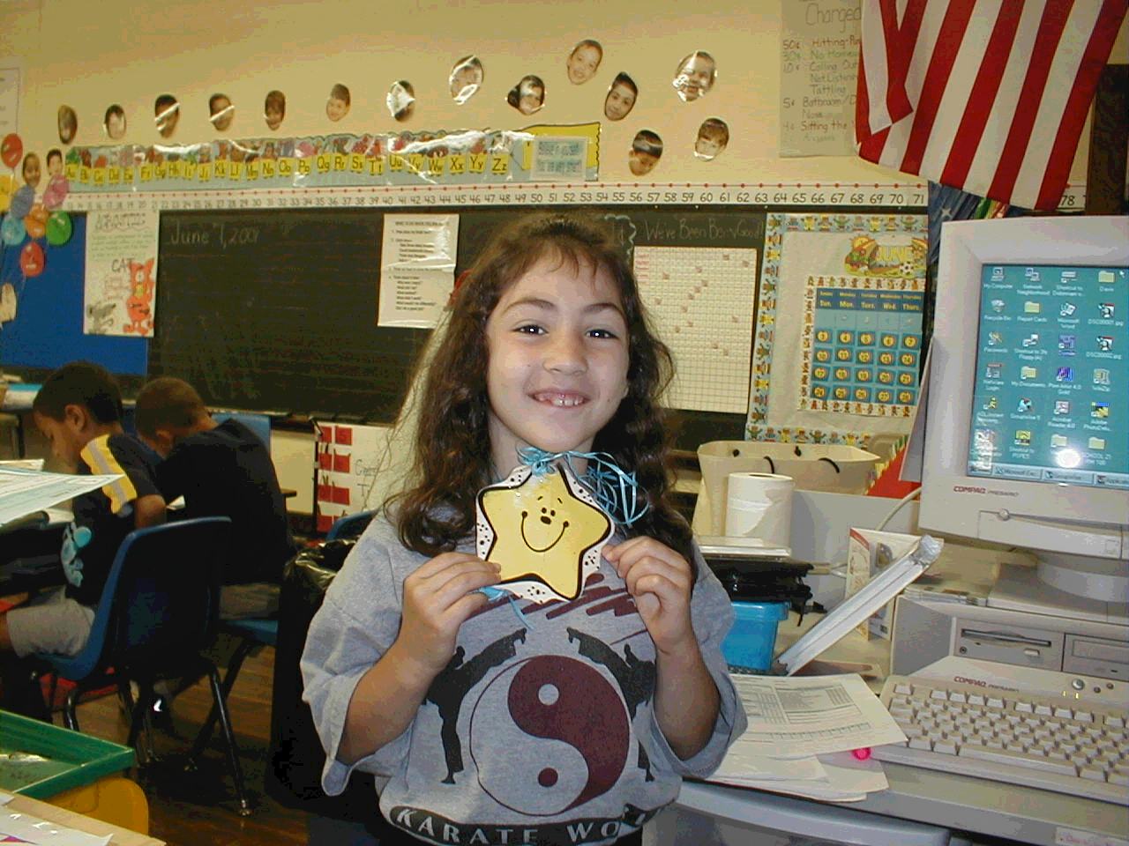
Anthony Markowitz

Miss Davis: What is your favorite color?
Lia:
Miss Davis: Why is blue your favorite color?
Lia:
Miss Davis: If you could have any pet, what would it be?
Lia:
Miss Davis: Why would you want a dog?
Lia:
Miss Davis: What would you like to say to your mom and dad?
Lia:
Miss Davis: What did you like best about being Star Student?
Lia:

