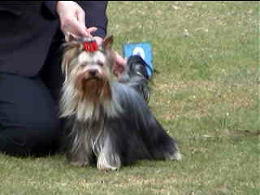 | 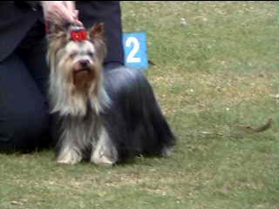
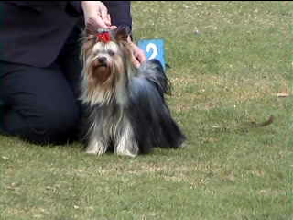 | 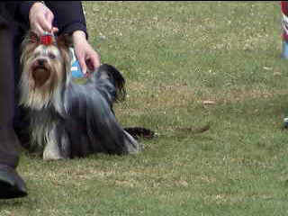

THIS IS SIGGE’S FIRST SHOW ON 15TH SEPT. 2004.
HE TOOK DOG CHALLENGE AND RUNNER UP BEST OF BREED

