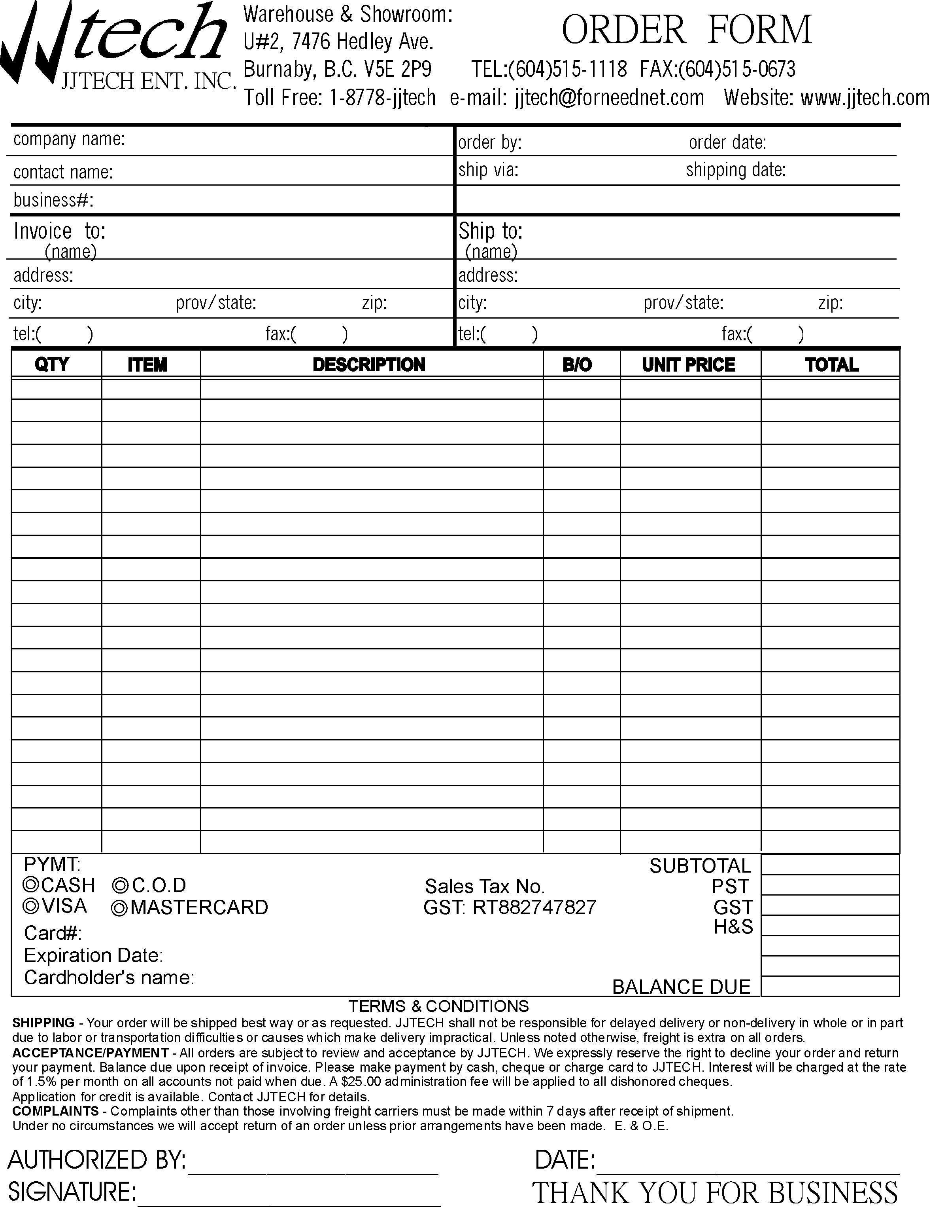
Please Print this form for your order and fax to :604-5150673

