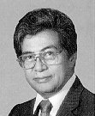Akaka, Daniel (D-HI) Class I NJ CC Score 16
Senator Daniel Kahikina Akaka, the only Chinese-American in the Senate, is the junior senator from Hawaii. He was appointed to the Senate in April of 1990 after the death of Senator Spark M. Matsunaga. He also served seven consecutive terms in the U.S. House of Representatives before his appointment to the Senate. A democrat, Senator Akaka tends to vote pro-choice and pro-gun control. He also supports pardoning of most illegal immigrants. He has not supported either of President Bush’s tax cut plans. Finally, he did not support the resolution supporting the use of force in Iraq. Senator Akaka is especially concerned with economic education of children. He served as a teacher and principal in Hawaii in the 1960’s, and worked in an economic advisory office in the Governor’s office before being elected to the House of Representatives in the early 1970’s. He is also concerned with the welfare of indigenous peoples, and he works to maintain what his website calls “the excellent relationship between the state of Hawaii and the Department of Defense.”

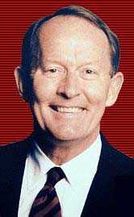Alexander, Lamar R-TN Class II NJ CC Score: N/A
Senator Lamar Alexander is the junior senator from Tennessee. He was elected to the Senate in November of 2002, defeating democrat Bob Clement to take over the Senate seat being vacated by former Senator Fred Thompson. He ran as a primary election candidate for President in 2000. He has also served as Governor of Tennessee and US Secretary of Education under President George H.W. Bush. A republican, Senator Alexander is a freshman senator and thus has not compiled much of a voting record to this point. However, he did vote in favor of Senate Bill S3, the partial birth abortion ban. Also, he supported the war in Iraq and the President’s latest tax cut. Senator Alexander believes in the use of charter schools over more traditional public schools, and he believes in setting aside as many as 2000 acres of the 19.5 million acres in the Artic National Wildlife Refuge for oil drilling in order to reduce dependence on foreign oil.

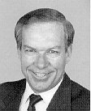Allard, Wayne R-CO Class II National Journal Conservative Composite: 85
Senator Wayne A. Allard is the junior senator from Colorado. He was elected to the Senate in 1996, previously serving three terms in the US House of Representatives and the Colorado State Senate. Senator Allard is a licensed veterinarian, earning his DVM from Colorado State University in 1966. He and his wife, Joan, founded Allard Animal Hospital in 1970. A republican, Senator Allard votes pro-life, and generally opposes gun control measures. Senator Allard is a strong believer in the “citizen legislator” as he continued to run his veterinary practice full time while working in the Colorado State Senate. He also holds town meetings in all 64 Colorado counties every year, and maintains a 99% voting record in the Senate. Senator Allard also is a staunch supporter of small business, compiling a near-perfect voting record of supporting tax cuts and credits for small business owners.

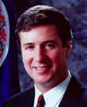Allen, George R-VA Class I NJCC : 73
Senator George Felix Allen is the junior senator from Virginia. He was elected to the Senate in 2000. Previously, Allen served as the Governor of Virginia from 1994-1998. He also served one term in the US House of Representatives from 91-93, and eight years in the Virginia House of Delegates, from 1983-91. A republican, Senator Allen votes pro-life, generally anti-gun control, and he supported the resolution authorizing the use of force in Iraq. He also supported both of President Bush’s tax cut plans. Senator Allen believes in offering families with students a $1000 tax credit to help pay for computers, books, and other school supplies. He also believes in strengthening the military, increasing the numbers of teachers in schools, and in tax breaks for families and small businesses.

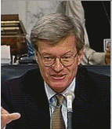Baucus, Max D-MT Class II NJCC: 42
Senator Max S. Baucus is the senior senator from Montana. Senator Baucus was first elected to the Senate in 1978, and he has been re-elected four times. Previously, he served two terms in the US House of Representatives and one term in the Montana House of Representatives. A moderate democrat, Senator Baucus votes pro-choice but generally opposes gun-control measures. He also supported President Bush’s first tax cut plan in 2001, and he supported the resolution authorizing use of force in Iraq. However, he did not support the President’s latest tax cut proposal. Senator Baucus has stated that his priorities for this term in office include creation of more good-paying jobs for Montanans, passing a prescription drug reform bill, providing agricultural disaster aid to farmers and ranchers in the Western United States, and writing a highway bill to bring more federal dollars and highway jobs to Montana.

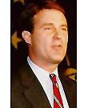Bayh, Evan D-IN Class III NJCC 41
B. Evan Bayh is the junior senator from Indiana. Senator Bayh was elected to the Senate in 1998 after serving eight years as Governor of Indiana. He also served as Indiana Secretary of State from 1986-1989. A democrat, Senator Bayh generally votes pro-choice but supported the partial-birth abortion ban. He also favors gun-control measures. He did not support either the 2001 tax cuts or the 2003 tax cuts. He did support the resolution authorizing the use of force to debunk the regime of Saddam Hussein. Interestingly enough, Bayh lists among his priorities on his website to “Overhaul the tax code to make it flatter and fairer while protecting working families from a tax increase.” He also supports limited tax cuts as long as they do not put the balanced budget in jeopardy. Finally, Bayh has sponsored legislation that would attempt to make more fathers support their families, and hold fathers responsible for the actions of their children.

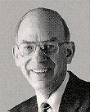Bennett, Robert R-UT Class III NJCC 83
Senator Robert F. Bennett is the junior senator from Utah. Senator Bennett had no previous political experience before being elected to the Senate in 1992. He was the CEO of Franklin Quest (now called FranklinCovey) a chain and catalog business that sells office and productivity supplies. A republican, Senator Bennett votes pro-life and generally opposes gun control measures. He also supported both of the tax cut proposals and the resolution authorizing the use of force in Iraq. Senator Bennett is a champion of high-tech legislation. He sponsored legislation to combat the Y2K computer glitch, and has sponsored several other pieces of internet-related legislation.

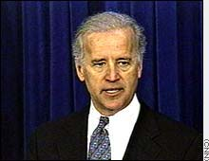Biden, Joseph D-DE Class II NJCC 25
Senator Joseph R. Biden Jr. is the senior senator from Delaware. Biden served on the New Castle County Castle before being elected Senator in 1972. A liberal democrat, Senator Biden firmly pro-choice, is a staunch supporter of gun control, and tends to favor measures that support organized labor over measures that would support self-employed persons and small businesses. He also is a strong supporter of environmental and animal rights bills. Senator Biden supported the resolution authorizing the use of force in Iraq, but he did not support either of President Bush’s tax cut proposals. Senator Biden has been a key in crafting many of the crime bills passed in the last ten years in the Senate, including the Violence Against Women Act (VAWA) in 2000. Finally, Senator Biden has authored legislation authorizing tax cuts for post-secondary students.

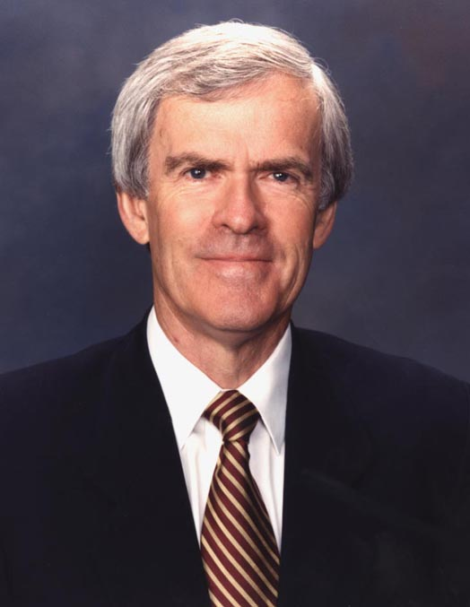Bingaman, Jeff D-NM Class I NJCC 23
Senator Jeff Bingaman is the junior senator from New Mexico. Senator Bingaman served as the Attorney General for the state of New Mexico from 1979-1982 before being elected Senator in 1982. A liberal democrat, Senator Bingaman is staunchly pro-choice and pro-gun control. He voted against Senate Bill S3 (108th Congress) which passed, effectively banning the medical procedure known as a “partial-birth abortion.” Senator Bingaman also voted against the resolution authorizing the use of force in Iraq, and he did not support either tax cut proposal. He supports development of what his website calls “dual-use” technologies, meaning technologies that could be used in both military and civilian uses.

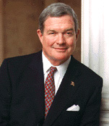Bond, Christopher R-MO Class III NJCC 77
Senator Christopher S. “Kit” Bond is the senior senator from Missouri. Senator Bond served from 1973-77 and from 1981-85 as Governor of Missouri. He was elected to the Senate in 1986. A republican, Senator Bond is strongly pro-life and generally opposes gun control issues. In addition, he generally supports measures supporting self-employed persons and small business over measures that would support organized labor and large corporations. Senator Bond also supported the resolution authorizing the use of force in Iraq, and he supported both of President Bush’s tax cut proposals. He supports uniform national voting standards, and is an advocate for the cleanup and restoration of the Missouri River.

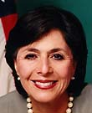Boxer, Barbara D-CA Class III NJCC 7
Senator Barbara Boxer is the junior senator from California. Senator Boxer previously served in the United States House of Representatives from 1982-1992 before being elected to the Senate in 1992. Ms. Boxer, one of the Senate’s most liberal members, is fiercely pro-choice and pro-gun control. She did not support the resolution authorizing the use of force in Iraq, and she did not support either of President Bush’s tax cut proposals. Senator Boxer generally does not support raising funding to the Department of Defense, and she supports legalizing marijuana for medicinal use, “If a physician feels that a controlled substance is the only thing to stop pain, I support such use with a prescription and strict controls.”
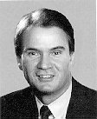Breaux, John D-LA Class III NJCC 50
Senator John B. Breaux is the senior Senator from Louisiana. Senator Breaux served in the US House of Representatives from 1972-1986 before being elected to former Senator Russell Long’s seat in 1986. A moderate democrat, Senator Breaux is pro-life and generally pro-gun control. He also supports many measures benefiting organized labor. Senator Breaux has been praised by several media outlets for working with both parties, and voting on the issues rather than on party lines. He voted for the partial birth abortion ban, the resolution supporting the use of force in Iraq, and the 2001 tax cut proposal, but he did not support the President’s latest tax cut proposal. Senator Breaux also supported the
Brownback, Sam R-KS Class III
Bunning, Jim R-KY Class III
Burns, Conrad R-MT Class I
Byrd, Robert D-WV Class I
Campbell, Ben R-CO Class III
Cantwell, Maria D-WA Class I
Carper, Thomas D-DE Class I
Chafee, Lincoln R-RI Class I
Chambliss, Saxby R-GA Class II
Clinton, Hillary D-NY Class I
Cochran, Thad R-MS Class II
Coleman, Norm R-MN Class II
Collins, Susan R-ME Class II
Conrad, Kent D-ND Class I
Cornyn, John R-TX Class II
Corzine, Jon D-NJ Class I
Craig, Larry R-ID Class II
Crapo, Michael R-ID Class III
Daschle, Thomas D-SD Class III
Dayton, Mark D-MN Class I
DeWine, Mike R-OH Class I
Dodd, Christopher D-CT Class III
Dole, Elizabeth R-NC Class II
Domenici, Pete R-NM Class II
Dorgan, Byron D-ND Class III
Durbin, Richard D-IL Class II
Edwards, John D-NC Class III
Ensign, John R-NV Class I
Enzi, Michael R-WY Class II
Feingold, Russell D-WI Class III
Feinstein, Dianne D-CA Class I
Fitzgerald, Peter R-IL Class III
Frist, Bill R-TN Class I
Graham, Bob D-FL Class III
Graham, Lindsey R-SC Class II
Grassley, Chuck R-IA Class III
Gregg, Judd R-NH Class III
Hagel, Chuck R-NE Class III
Harkin, Tom D-IA Class II
Hatch, Orrin R-UT Class I
Hollings, Ernest D-SC Class III
Hutchison, Kay R-TX Class I
Inhofe, James R-OK Class II
Inouye, Daniel D-HI Class III
Jeffords, James I-VT Class I
Johnson, Tim D-SD Class II
Kennedy, Edward D-MA Class I
Kerry, John D-MA Class II
Kohl, Herb D-WI Class I
Kyl, Jon R-AZ Class I
Landrieu, Mary D-LA Class II
Lautenberg, Frank D-NJ Class II
Leahy, Patrick D-VT Class III
Levin, Carl D-MI Class II
Lieberman, Joseph D-CT Class I
Lincoln, Blanche D-AR Class III
Lott, Trent R-MS Class I
Lugar, Richard R-IN Class I
McCain, John R-AZ Class III
McConnell, Mitch R-KY Class II
Mikulski, Barbara D-MD Class III
Miller, Zell D-GA Class III
Murkowski, Lisa R-AK Class III
Murray, Patty D-WA Class III
Nelson, Bill D-FL Class I
Nelson, Ben D-NE Class I
Nickles, Don R-OK Class III
Pryor, Mark D-AR Class II
Reed, Jack D-RI Class II
Reid, Harry D-NV Class III
Roberts, Pat R-KS Class II
Rockefeller, John D-WV Class II
Santorum, Rick R-PA Class I
Sarbanes, Paul D-MD Class I
Schumer, Charles, D-NY Class III
Sessions, Jeff R-AL Class II
Shelby, Richard R-Al Class III
Smith, Gordon R-OR Class II
Snowe, Olympia R-ME Class I
Specter, Arlen R-PA Class III
Stabenow, Debbie D-MI Class I
Stevens, Ted R-AK Class II
Sununu, John R-NH Class II
Talent, James R-MO Class I
Thomas, Craig R-WY Class I
Voinovich, George R-OH Class III
Warner, John R-VA Class II
Wyden, Ron D-OR Class III

