Model Manager: A Visually Programmed, Model Themed
Data-Flow Programming Language for Robot Control

William J Schonlau*
Modular Motion Systems Corporation

ABSTRACT

An experimental modeling language for general purpose simulation, robotic control and factory automation is presented. The advantages of a visual programming interface and data flow architecture are examined. Primarily, the model based organization is proposed as a means of integrating various intelligent systems disciplines to enhance problem solving abilities and improve system utility.

Keywords: model, data-flow, visual, programming, language, intelligent, robot, simulation, control, automation

- INTRODUCTION

Model Manager is an experimental modeling language intended primarily for robotic control and simulation. An important goal of the design is the integration of selected intelligent systems disciplines to achieve flexibility and useful problem solving capabilities. It is proposed that these capabilities are most conveniently utilized through a graphically programmed user interface that improves user perception of task structure, ease of application programming and visibility of task execution status. It is further proposed that a data flow programming paradigm expedites a virtual parallelism conducive to the application of machine intelligence disciplines that have achieved impressive levels of performance in relatively isolated settings and may now be more suited to some degree of cooperative integration.

  - Concept

The Model Manager provides the user with (1) an abstract hierarchical view of the application domain as embodied by the model, (2) a means to add, delete or modify components of that domain and (3) a dynamic view of those components that are imageable from a user controlled viewpoint in the virtual space. An expanding library of computational and structural primitives is provided for the construction of application domain specific library composites. As they are developed, these composites become available for building models of increasingly complex systems, either at the users direction or by the action of model synthesis primitives that the user can employ at higher levels of the model. Model nodes may incorporate cyclic-agent threads, presented in greater detail below, that effectively achieve a high degree of procedural parallelism for all model components. The global model is always active but the user may disable specific nodes for editing to avoid problematic behavior in incomplete model components.

  - Goal

The intended uses include simulation, off line programming of robotic applications and realtime control of multiple cooperating robotic systems. The disciplines of knowledge representation, machine vision, planning, natural language understanding and motion control have consistently moved forward while the substantial hardware resources needed to field such systems have become much less expensive, smaller, lighter, more reliable and consume much less power. The goal here is to provide a software architecture that will allow these disciplines to collaborate to the greatest possible degree to make robotic systems easier to use, more productive and more cost effective. It is hoped that the internal model of the real world activity will host a fruitful integration of sensor data exploitation and dynamic process planning.

BACKGROUND

  - Data flow and visual programming

A data-flow vs control-flow dichotomy is often imposed on computing hardware and software architectures, some papers note an equivalence of data flow and functional language designs. While much interesting work has been done in the area of visually programmed data-flow computing and presented in the extensive literature on this subject [1,2], important aspects of implementation remain somewhat application dependent.

The interest here is in the efficiency attained by only computing new model-node output values when node inputs have changed and achieving virtual parallelism by allowing new values to enter a model asynchronously at many locations. Some interesting questions arise concerning the initiation of node recalculation, i.e. based on a single new input or a full set of new inputs, the experimental techniques implemented in this system are discussed below.

The popularity of visual programming methods is clearly increasing, as witnessed by the proliferation of published work and conference activity [3,4]. There is extensive literature discussing the theory of visual programming methods and surveying the many systems that have been developed, references [5-8] present an excellent overview of work in this area.

The focus here is on visualization of program structure, the development of a library of useful primitives and the construction of a composite program library using easily understood visual tools.

  - Commercial products

Several commercially available visual programming systems have been developed, KBVision, SimuLink and LabView to name just a few. The major difference between Model Manager design goals and these systems is the generalization of model scope, integration of physical structure with computational data flow in the model and using the same program construct for either real time robotic control or simulation.

INTELLIGENT SYSTEMS

  - Relevant disciplines

The primary goal of the Model Manager architecture is the provision of a platform that can host the cooperative integration of the many disciplines that have emerged within the artificial intelligence research community. While it is not established that this is a practical objective, any progress or marginal success here may prove quite fruitful. The various fields that should be explored would include Knowledge Representation, Planning, Vision, Motion Control, Learning, Inference, Rule Based Systems, Neural Networks and Expert Systems. A thoughtful discussion of each topic is not within the scope of this paper but a few comments are offered.

The interest here is the achievement of flexibility and problem solving capabilities that will make a robotic system more self sufficient, more easily programmable and able to improvise some task execution procedures autonomously. The intelligent systems disciplines most expeditious to near term achievement of these goals may be the recent advances in machine vision and planning.

  - Machine vision

Very helpful in the robotic systems context is the use of line models for machine vision, for an informative review see [9,10]. Generally, the preferred approach to line model based vision is to generate hypotheses about objects that are expected to appear in a digitized image from a list of line structures extracted from the image and scoring these hypotheses on the basis of alignment with other line structures. In the 2D domain this is easily done in real time, the 3D line model procedure requires more search, more computing power and needs further development.

Some robotic system developers have expressed the opinion that safety is one of the most critical issues facing the industry in the near term. More capable vision systems may be able to serve this need by halting operation operation when large unexplained objects enter into images of the workspace.

  - Planning

The incorporation of support for procedural planning capabilities is primarily intended to provide the user with the ability with high level abstract instructions. The effective use of planning algorithms requires extensive knowledge of the problem domain in general, and detailed information about the domain instance at hand. The model addresses the latter issue directly, while the former requires a prepared knowledge base, possibly in the form of production system rules or an expert system.

A recent issue of the AAAI Magazine was dedicated to advances in Continuous and Distributed Planning and one paper presented an instructive survey of recent work, see reference [11]. The initial efforts to develop Model Manager primitives that provide this capability, however, have followed the methods employed in the early GPS program, see reference [12], with plans for the addition of a state optimization method.

Implementation

  - Java language

The Java programming language and libraries were chosen to host the Model Manager because it offers platform independence and several important support libraries. The user interface makes extensive use of the Swing library and COM port communications with other factory systems and instruments is supported by the JavaComm library, with USB support scheduled for distribution sometime this year. In addition, a flexible 3D rendering engine, Java3D, is available for simulation displays, providing a dynamic viewpoint that the user may navigate in real time.

  - Data-flow implementation

The Model Manager represents a system model as a hierarchical or tree-structured collection of nodes, each having input and output ports. Data values are stored in the output ports, which have links to the input ports of other nodes. When new data values are presented at output ports, that port is added to a FIFO queue of data sources. This queue is processed sequentially, oldest entry first, by querying all connected nodes about the sufficiency of their current set of new inputs for recalculation. If activation requirements are satisfied, the node is recalculated; for composite nodes this is done by recursively creating a new context for node evaluation and reapplying the same procedure, while primitive nodes are simply computed by the associated code in the primitive library. When calculating a composite node, this procedure provides a breadth first traversal of the component node network, cooperating with a depth first traversal of the model tree within those components.

Some experimentation with different algorithms for defining the sufficiency of the current set of new inputs was performed. The most satisfactory scheme for initiating node recalculation was allowing the user to define a trigger-set of input ports that would required new values for recalculation to occur, but other simpler methods, like any new input while all inputs are defined, have proven adequate.

  - Data types

When node ports are created, data types are assigned. The currently supported types are shown in Table 1. The generic object type is useful for composing arbitrary data structures for distribution as a single entity.

DATA TYPE | REPRESENTATION
int, int array | IEEE standard 32 bit integer.
float, float array, matrix | IEEE standard 32 bit floating point number.
string, string array | Null terminated ASCII character string.
object | Data structure composed by STRUCT primitive.

Table 1. Model Manager Data Types.

  - Graphic user interface

A simple two window user interface, as shown in Figure 1, allows the user to select a model node for editing and make desired changes to that node. The left window is a scrollable view of the hierarchical model tree that branches out from the root node on the left edge to all of the root node components in the column on its immediate right. This rule of structure recurses for each of those components with all branches ultimately terminating on primitive nodes, which have no component structure.

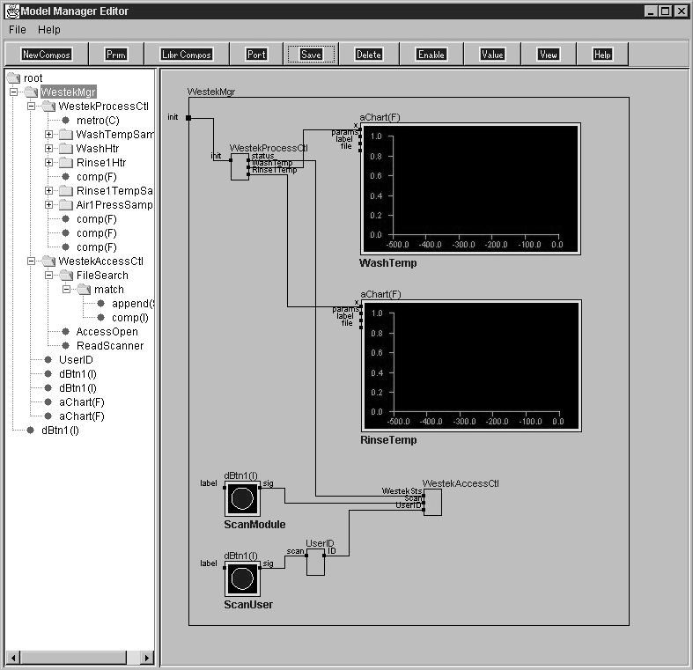

Figure 1. Two window user interface of Model Manager.

Any node the user selects in this tree window, then referred to as a parent node, has its internal structure displayed in the right window where all editing takes place. The internal structure is shown as a collection of component nodes connected by data-flow path lines to each other and/or the parent node ports. The editing process consists of (1) node placement and (2) node port interconnection. Node placement consists of selecting nodes from the primitive library, the composite library or creating a new node. Port interconnection consists of drawing a line from an output port of some node to an input port of another by dragging the mouse pointer. Generally, the interface will not allow the connection of incompatible port types but a full set of type conversion primitives is provided . The line will be automatically routed but the user may drag the corners of the connection path to new locations to make a more attractive display. Nodes may also be moved about by similar means for organizational clarity and appearance.

Instead of menus, a tool bar provides a row of buttons, one for each of the major editing operations, again see the top of Figure 2. The functionality of each button is summarized in Table 2.

BUTTON | FUNCTIONALITY
New Composite | Create empty shell for construction of new composite node.
Libr Composite | Load existing composite node from library file.
Primitive | Insert primitive node from library list.
New Port | Create new port for current parent node (I/O, data type).
Delete | Remove selected item (node, port, link) from model.
Value | Define default value for selected port.
Enable/Disable | Disable (enable) node calculation for editing.
View | Create view window showing simulation activity.
Save | Save selected (parent) node in library file.
Help | User instruction.

Table 2. Model Manager toolbar buttons.

  - Primitives

Every effort is made to provide a complete set of primitive nodes that will meet all of the user’s computational needs. The Model Manager primitive groupings are shown in Table 3. All models are ultimately composed of primitive computations, tied together by data pathways to perform some useful function.

PRIMITIVE GROUP | FUNCTIONALITY
Scalar functions | Integer and float calculations.
Vector functions | Vector calculations and operators.
Matrix functions | Matrix calculations and operators.
String functions | String search, extraction and composition operators.
File functions | Data file creation, access and extension operators.
Programming primitives | Agents, conditional and control flow operators.
Data display | Digital and chart displays (1, 2 and 3D).
Data entry | Keyboard, analog control and sensor data entry.
Motion control | Actuator and arm control operators.

Table 3. Model Manager primitive groups.

It is a primary goal of experimentation with the Model Manager program that primitives will be developed that accept simple high level instructions and perform relatively complex tasks, invoking whatever intelligence may be required internally. Such primitives will not be easy to design but any progress made there will be very useful. For now, most of the current complement of primitives are similar to those found in existing software products.

  - Composites

As models are constructed, any node that provides a useful service may be saved in a composite library. These composites may then be used as building blocks for other more complex models. Limiting inputs and outputs to the ports of the top level node encourages well structured model design and reuse of the node in other models. This “portable composites” objective is similar in nature to the “intelligent primitives” goal expressed above, a sentiment that has permeated software systems design and evolution for a great many years.

In addition, the boundary between primitive and composite nodes may be somewhat synthetic, the categories differing only in efficiency, i.e. compiled code in the primitive and interpreted model structure in the composite. The real distinction here is “prepackaged” versus “user developed” model components, with a single method for incorporating either type into a model and easy migration of useful composites into the primitive library.

  - View window

As noted above in Table 2, the VIEW button creates a third window that displays those model components that are viewable as 3D objects and visible from the current viewpoint, see Figure 2. The view window provides navigation controls at the bottom of the frame that allow the user to move forward or back along the line of sight and to turn to the right or left, defining a new line of sight. More flexible navigation controls are currently under development. The motion or behavior of items in the model are generally controlled by the scalar (slide) or 2D (joystick) analog input primitives the user has placed in the model, although model entities may generate their own behavior.

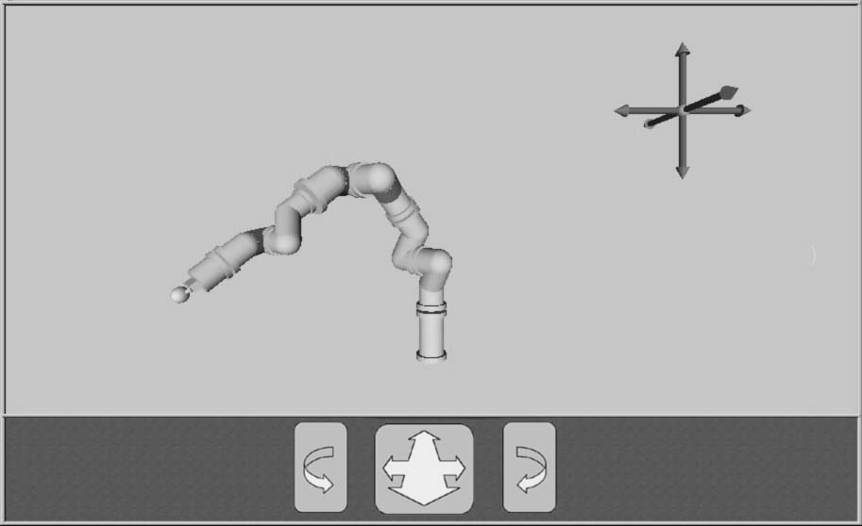

Figure 2. View window showing viewable model components and navigation controls.

The image rendering process is managed by the Java3D utility, which uses a hierarchical scene-graph to organize object geometry primitives, transformations, surface properties and lighting. When models are built, those library primitives having the “viewable” property are linked to corresponding entries created in the scene graph. Composite items loaded from the library are scanned for viewable components and processed similarly.

APPLICATION

  - MMS Architecture

The Model Manager program has been developed largely to support the Modular Motion Systems (MMS) robotic system, which is described in greater detail in references [13,14]. The MMS system provides an array of 1-degree-of-freedom (1-DOF) motion modules that a user may configure to suit a specific application. Figure 3 shows the module types, each of which is available in 5, 7, 10, 14 and 20 cm diameters. An introductory tutorial video and video clips showing MMS arms performing sample tasks is shown at the MMS website (www.mms-robots.com). The Model Manager runs on a standard desktop processor, providing the MMS hardware with a centralized control process for a single or multiple manipulator configuration, sensory data fusion, off-line task programming and real time task execution or simulation.

JOINT  modules  (active) | 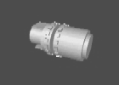  Rotary Joint | 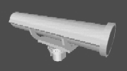  Linear Joint
LINK  modules  (passive) | 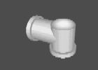  Elbow Link | 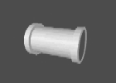  Straight Link

Figure 3. MMS module types.

The joint modules are high performance motor driven actuators with onboard processors and power amplifiers while the link modules are passive structural members. Figure 4 shows a standard 6-DOF PUMA configuration assembled from 6 1-DOF MMS rotary joint modules and the two types of link modules, all of either 7 cm (below elbow) or 10 cm (above elbow) diameters.

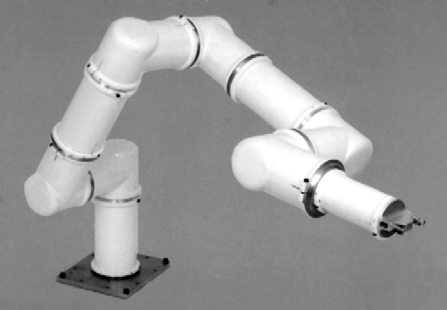

Figure 4. MMS rotary modules assembled in a PUMA configuration.

  - Configuration

The user may configure simple or complex designs as required for the intended application. but mathematical solutions are not generally available for novel configurations. To address this problem, the Model Manager provides a primitive that incorporates a Fuzzy Associative Memory (FAM) system, see reference [15] that generates a solution for the arm (or arms) configuration as defined, taking advantage of the detailed geometry information implicit in the model. This FAM system then provides real-time kinematic solutions for either simulation or operation of the arm configuration in the factory or laboratory.

  - Task Programming

While others have approached the visual programming of robotic tasks with a dichotomy of structure versus procedure [16,17], the Model Manager keeps the structure of task programs the same as the structure of other system models, with the action primitives passing command completion codes from each to the next upon completion of movements. The process may be thought of as a control-flow “token” passing sequentially through the program until the program runs to completion or some exception condition or BREAK command is encountered. The internal EventSchedule utility, the basis of cyclic-agent support, allows the real or simulated move to proceed without any processor burden while waiting for completion of a move. Visual continuity in the simulation is achieved through use of the alpha methods in the Java3D library.

Locations in the task workspace are defined as global variables in the scope of the task node and are referenced symbolically, allowing dynamic redefinition with information from vision, planning and inference engine components. Locations may be initialized in reference to objects that appear in the workspace model or using a manipulator end effector that is positioned in the workspace with the virtual 3D pendant shown in Figure 3. The virtual pendant directs motion of the end effector or tool without reference to the Cartesian frame of reference by clicking on the 3 bipolar orthogonal arrows shown in the figure, the farther from the center of the arrow one clicks, the larger the end effector movement.

The most satisfactory robot control scheme examined thus far emphasizes the use of GET and PUT primitives in the application program model. It is planned that these primitives will use information about the objects to be manipulated to select gripper pose, opening size and expected load forces while orchestrating gripper open-close action at the beginning or end of the move. Some of the higher level control primitives under development are shown in Table 4.

CONTROL PRIMTIVE | FUNCTION
GET | Move along efficient path to named location and close gripper.
PUT | Move along efficient path to named location and open gripper.
PATH | Move along smooth defined path while operating tool process.
FIND | Locate instances of know objects with visual sensors.
GROUP | Assign multiagent cooperative group.

Table 4. Robot control primitives.

The GET, PUT and PATH primitives require a program input that specifies a sequence of pose points defining the motion path, which are specified relative to named locations. Other inputs allow the program to specify such parameters as speed, acceleration, compliance and approach, thereby overriding default values. Generally, the GET and PUT primitives are intended for assembly or packaging tasks, requiring only endpoints while interpolating an efficient and collision free path. The PATH primitive is intended for tool actions like surface processing or adhesive application. The command applies a cubic spline interpolation algorithm that causes control points along a straight line to produce good path linearity with constant velocity and points along a curve to similarly produce smooth circular arcs.

Controlling multiple manipulators from a single model facilitates multi agent cooperation. The GROUP primitive creates a virtual cooperative group that enables several manipulators or autonomous robots to work together on the same task. Sensory information from all systems is fused in the central model, supporting coordinated group instruction.

CONCLUSIONS

The design principles embodied in the Model Manager software have shown good utility and usage experience has been pleasing, encouraging further development. The data-flow driven parallelism appears to work well with the visual programming methodology, encouraging the user to employ intuitive or common sense approaches to problems. The visual programming techniques have proven easy to use and application development experiences have been productive and disinclined to programming errors. The model based hierarchical structure does not appear to seriously compromise execution speed or efficiency, so long as the primitive library can provide high level building blocks that meet the user’s needs.

Perhaps the most daunting challenge to a fully adequate implementation of these methods is the development of clear and intuitive definitions of high level primitives that provide adequate degrees of self sufficiency without excessively constraining the user’s options. This problem of innate primitive intelligence seems similar to the difficulties software developers have always faced in designing software libraries.

ACKNOWLEDGEMENTS

The development of the Model Manager program has been supported solely by the Modular Motion Systems Corporation. The Model Manager software is protected by US Copyrights and is a component of the MMS robotic system which is protected by US and international patents.

REFERENCES

1. Hils, D.D., “Visual languages and computing survey: Data flow visual programming languages,” Journal of Visual Languages and Computing, 3:69-101, 1992.

2. Oberlander, Jon, Paul Brna, Richard Cox, Judith Good, “The GRIP Project, or... The Match-Mismatch Conjecture and Learning to Use Data-Flow Visual Programming Languages,” Collaborative project between HCRC, The University of Edinburgh & CBLU, The University of Leeds, April 1997 to September 1999.

3. Visual Language Research Bibliography, see the website http://www.cs.orst.edu/~burnett/vpl.html#V2A3.

4. IEEE Symposium on Visual Languages (VL), see the website http://VisualLanguages.ksi.edu/.

5. Najork. Marc, “Programming in Three Dimensions,” Journal of Visual Languages and Computing 7(2):219-242, June 1996.

6. Erwig. Martin, “Semantics of Visual Languages,” 13th IEEE Symp. on Visual Languages (VL'97), 304-311, 1997.

7. Burnett, Margaret, Marla Baker, "A Classification System for Visual Programming Languages," Journal of Visual Languages and Computing, September 1994, 287-300.

8. Ibrahim, Bertrand, “Semiformal Visual Languages, Visual Programming at a Higher Level of Abstraction,” World Multiconference on Systemics, Cybernetics and Informatics (SCI'99 and ISAS'99), Orlando, Florida, July 1999, 157-164.

- Beveridge, J. R., E. M. Riseman, “How Easy Is Matching 2D Line Models Using Local Search?”, IEEE Transactions on Pattern Analysis and Machine Intelligence (PAMI) (19), No. 6, June 1997, pp. 564-579.

10. Schonlau, W., "Line Model Algorithms for Vision", to be published, see the website http://www.mms-robots.com.

11. desJardins, Marie E., Edmund H. Durfee, Charles L. Ortiz, Jr., and Michael J. Wolverton, “A Survey of Research in Distributed, Continual Planning”, Vol 20(4): Winter 1999, 13-22.

12. Barr, A., E. A. Feigenbaum, “General Problem Solver (GPS) ”, developed by Newell, Shaw and Simon, in Handbook of Artificial Intelligence, Vol 1, Article II.D.2, 113-118, 1981.

13. Schonlau, W., "MMS, a Modular Robotic System and Model-Based Control Architecture", SPIE Sensor Fusion and Decentralized Control in Robotic Systems, Boston, Massachusettes, September 1999.

14. Schonlau, W., "A Modular Manipulator System (MMS), Architecture and Implementation", IEEE Intl Conf on Advanced Robotics, Monterey California, July 1997.

15. Schonlau, W., "Fuzzy Associative Memory System for Modular Robot Kinematics", to be published, see the website http://www.mms-robots.com.

16. Cox, Philip T., Trevor J. Smedley, “Visual Programming for Robot Control”, 1998 IEEE Symposium on Visual Languages, Halifax, Nova Scotia/Canada, Sept 98.

- Pfeiffer, Joseph J., “A Language for Geometric Reasoning in Mobile Robots”, 1999 IEEE Symposium on Visual Languages, Tokyo, Japan, September 1999.

* bill@mms-robots.com; phone and fax 310-544-7252; http://www.mms-robots.com; MMS, 31107 Marne Drive, Rancho Palos Verdes, CA, USA 90275.

