Applications of the
Spectrum Analyzer

Abstract
This paper was written for the purpose of documenting the process and results of the design of a Class-B amplifier circuit.

Introduction

The purpose of this lab is to familiarize ourselves with the Spectrum Analyzer. A Spectrum Analyzer is a more advanced version of an oscilloscope in which that it also displays the output in the frequency domain. This feature allows engineers to see frequency shifts in the frequency domain instead of the time domain. In many cases, the frequency domain provides more information, and results could be easily observed.
In the first section of the experiment, the result of passing a square wave and a triangle wave is examined. The second part of section A. deals with measuring and plot the frequency response of a simple single-pole low pass filter.
In the second section of the experiment, the usage of the spectrum analyzer is further explored by filtering out the different harmonics of a Butterworth Low Pass Filter.
The low pass filter designed would next be used to filter a 10 Vpp, 1 kHz square wave. A spectrum analyzer would also be used to examine this output. Lastly, we will compare the plots from the spectrum analyzer while with the Butterworth filter and without the filter.

Written by: Chieh Wu
Lab partner: John Process
Written: September 20, 2002

Experiment

Section A1
The purpose of this section is to insert a square wave and a triangle wave to observe the frequency harmonics output in the spectrum analyzer.

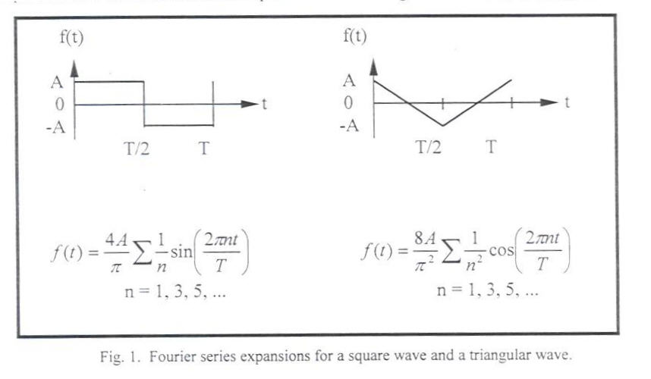
Figure 1 – Input Square and triangle wave

Theoretical Wave Amplitude (dBV)

 | Sine | Square | Triangle
n | Amplitude | Amplitude | Amplitude
1 | 3 | 2.54 | 1.62
3 |  | 0.84 | .18
5 |  | 0.51 | .065
7 |  | 0.364 | .033
9 |  | 0.283 | .02
11 |  | 0.23 | .013
13 |  | 0.2 | .0096
15 |  | 0.17 | .0072
17 |  | 0.15 | .0056
19 |  | 0.134 | .0045

Table 1 – Theoretical amplitude of each harmonic

Results:

Figure 2 – Output of a sine wave in frequency domain

Figure 3 – Output of a square wave in frequency domain

Figure 4 – Output of a triangle wave in frequency domain

 | Amplitude = 2V
 | Triangle Wave
 | experimental | experimental
n | harmonic rms(dBV) | harmonic amp.(V)
1 | 1.19 | 1.622
3 | -17.9 | 0.180
5 | -26.78 | 0.065
7 | -32.63 | 0.033
9 | -37.05 | 0.020
11 | -40.3 | 0.014
13 | -43.34 | 0.010
15 | -45.8 | 0.007
17 | -48.02 | 0.006
19 | -49.83 | 0.005
Table 2 – Experimental amplitude of each triangle harmonic

 | Amplitude = 2V
 | Square Wave
 | experimental | experimental
n | harmonic rms(dBV) | harmonic amp.(V)
1 | 5.12 | 2.55
3 | -4.43 | 0.849
5 | -8.86 | 0.51
7 | -11.79 | 0.364
9 | -13.96 | 0.283
11 | -15.71 | 0.232
13 | -17.6 | 0.186
15 | -18.4 | 0.17
17 | -19.49 | 0.15
19 | -20.46 | 0.134
Table 3 – Experimental amplitude of each square harmonic

The amplitude obtained from the spectrum analyzer was in terms of dB. To convert the amplitude from dB to voltage equation 2 is used.

$\text{dB}=\text{20}\text{log}(V_{\text{amplitude}})$ Eq – 1
$V_{\text{amplitude}}={\text{10}}^{\frac{\text{dB}}{\text{20}}}$ Eq - 2

The resulting output on the spectrum analyzer matched precisely with the expected output. Looking at the Fourier series of each voltage input, a sine wave would be an impulse function with a single frequency. The square wave would consist of infinite impulse because it also has infinite harmonics. The triangle wave would be in between a sine and a square.
As it could be seen from figure 2, 3, and 4 of the experimental results; the sine wave output resembles an impulse function, the square wave had an infinite numbers of harmonics, and the triangle wave appeared to have less harmonics (due to its faster amplitude drop). From these three figures, it could be concluded that the closer the input is to a sine wave, the quicker the drop of amplitude and less harmonics would exist in the Fourier series.

Section A2
The purpose of this section is to use the spectrum analyzer and plot the frequency response of a single-pole low pass filter.

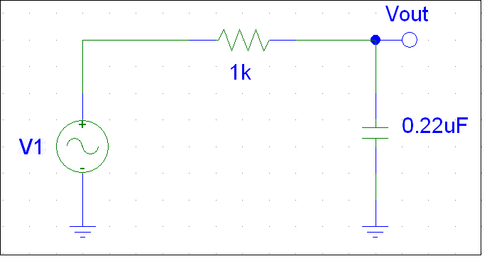
Figure 5 – Single-pole low pass filter

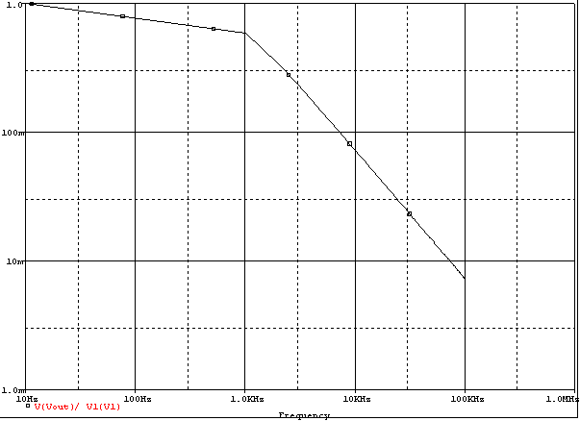
Figure 6 – The bode plot of the single-pole low pass filter (Pole at 1 kHz)

From the equation of the single-pole filter, the pole could be designed simply by manipulating the values of the capacitor and the resistor.

$\frac{V_{2}}{V_{1}}=\frac{1}{1+j2π\text{fRC}}$ Eq – 3

The frequency could be approximated by the equation:

$f≈\frac{1}{2π\text{RC}}$ Eq - 4

Section B1
The purpose of this section is to consider an asymmetrical square wave and what the Fourier series would look like in the spectrum analyzer.

Part a
The Fourier series for an asymmetrical square
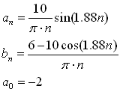
Part b
The 50% duty cycle square wave produces zero even harmonics. They still show up on the spectrum analyzer due to the imperfect wave input. However, it only exist in a small amplitude (-55dBV).
Part c
Figure 7– Asymmetric harmonics

Part d
1st harmonic = 4.18 V
2nd harmonic = 2.43 V
3rd harmonic = 0.67 V
 | Amplitude = 5V | Frequency = 1 kHz
 | Asym. Squ. Wave
 | experimental | experimental | theoretical
n | harmonic rms(dBV) | harmonic amp.(V) | harmonic amp.(V)
1 | 8.21 | 3.639 | 4.180
2 | 2.34 | 1.851 | 2.430
3 | -30.22 | 0.044 | 0.670
Table 4 – Experimental amplitude asymmetric harmonics

Section B2
The overall intent of this part is to emphasize the harmonics in Fourier series shows up in the spectrum analyzer after adding an active filter. The active filter used in this section is called the Butterworth Filters and it must be second-ordered, single op amp, with 3 dB frequency at 1 kHz.

The Two active filters are:
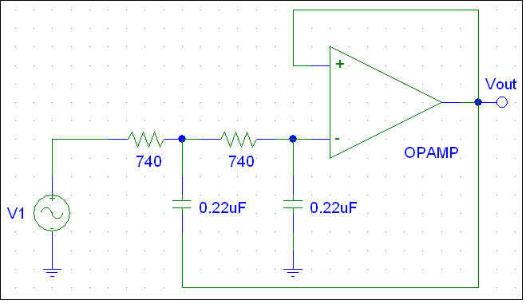
Figure 8– Single Op amp, second-order Low-Pass RC filter (a)
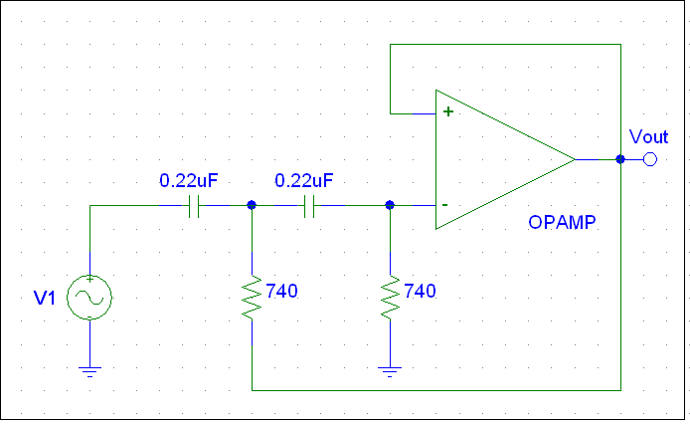
Figure 9– Single Op amp, second-order High-pass RC filter (b)
$ω_{o}=\frac{1}{2π\text{RC}}$ Eq - 5

Section B3
After designing the active filter, this section plots the transfer function shown on the analyzer.

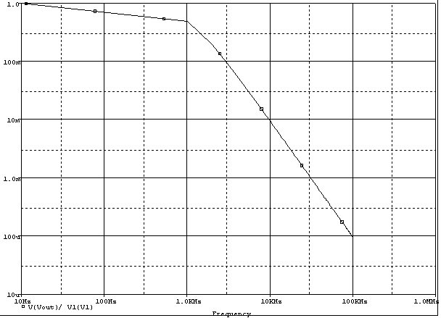
Figure 10– Transfer function using filter (a) Cutoff at 1 kHz, max gain = 1.

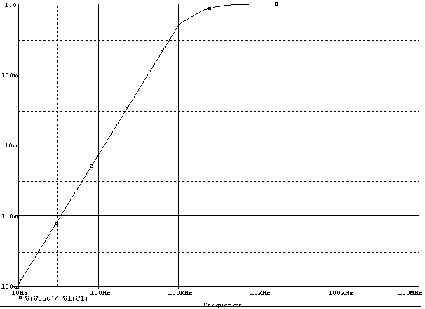
Figure 11– Transfer function using filter (b)
Cutoff at 1 kHz, max gain = 1.

The slope of the high frequencies from the figure above is about -40 dB/decade. This result followed the theoretical description because there are two poles in the circuit. Each pole would have a drop off of -20 dB/decade; together both poles would add up to -40 dB/decade at the frequency 1 kHz.

Section B4
This section discusses the output on a spectrum analyzer of a 10 Vpp, 1 kHz square waveform when it is connected to the Butterworth filter versus not connected to the filter.

 | Amplitude = 5V
 | Asym. Squ. Wave
 | Experimental | Experimental
n | harmonic rms(dBV) | harmonic amp.(V)
1 | 3.65 | 2.153
3 | -10.75 | 0.410
5 | -20.6 | 0.013
7 | -27.23 | 0.062
9 | -32.8 | 0.032
Table 5 – Experimental amplitude of each harmonic

Figure 12 – Spectrum analyzer plot with the filter

Figure 13 – Spectrum analyzer plot without the filter

From the plot above, it could be seen that the plot without the filter had much less attenuation while the plot with the filter started attenuating at 1 kHz. This outcome followed the designing guide. If the transfer function of the filter is superimposed upon the waveform, you could see the clipping done by the filter.

Section B5
This section plots the output of the filter using the oscilloscope.

Figure 12 – Oscilloscope plot with the low pass filter.

From the figure above, the square input signal came out the filter more similar to a sine wave. This is because the filter has taken away the higher harmonics from the Fourier series, by doing so; the number of frequencies in the signal reduces which cause it to appear closer to a single frequency wave (sinusoidal wave).
Class B Amplifier
This is an extra section which shows the harmonics created by crossover distortion in the class B amplifier from the previous lab. The input to the amplifier is a 4 Vp-p sine wave with a frequency of 10 kHz.

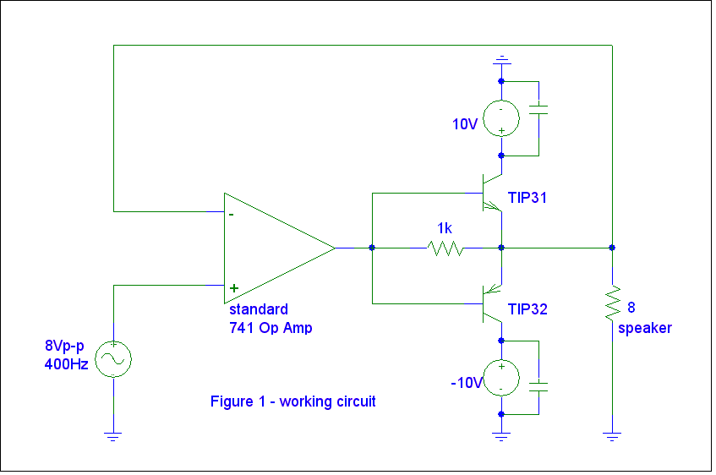
Figure 14 – Spectrum analyzer plot without the filter

 | Amplitude = 2V | Frequency = 10 kHz
 | Sine Wave
 | experimental | experimental
n | harmonic rms(dBV) | harmonic amp.(V)
1 | -1.36 | 1.209
2 | -43.8 | 0.009
3 | -16.7 | 0.207
4 | -45.8 | 0.007
5 | -23.9 | 0.090
Table 6 – Experimental amplitude of each harmonic

Figure 15 – Spectrum Analyzer display of the sine wave cross over distortion

Mixer
This last section discusses the working function of a broadband mixer.
The two input frequencies are 40 kHz and 6 kHz. Because there are two frequencies, this circuit combines many harmonics from the overlapping harmonics between the two frequencies. In the time domain, the higher frequency provides the envelope which in communication carries the information.

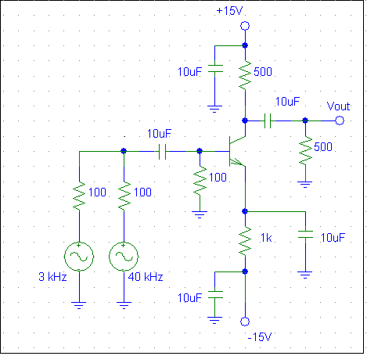
Figure 16 – Sample mixer circuit

Conclusion
It was not until this lab that the existence of a spectrum analyzer was even known to me. Although the oscilloscope is a powerful tool it does not provide the output voltage in the frequency domain. Unfortunately, for many cases the frequency domain provides much more information to the working engineers.
It is only possible with a spectrum analyzer that the different harmonics of a signal could be seen. For example, when a sine, triangle, and square waves were passed through the oscilloscope, the output would obviously be sine, triangle, and square. But from the figures in this lab, it has shown that the harmonics of the Fourier series could be inspected only by the spectrum analyzer. With the three different waveforms, it could be concluded that waveforms similar to a sine wave contains less harmonics.
Another aspect of this lab is the designing of the Butterworth low-pass filter. It is very useful because of its simple design. The pole could easily be determined by 1/RC. When the output of a square waveform is filtered, the attenuation could be seen on the oscilloscope similar to the bode plot of the low-pass filter.
In the class B amplifier, the spectrum analyzer also displayed high amplitudes in even harmonics. A perfect sine wave would not produce these harmonics, but due to the crossover distortion, more frequencies were added to the harmonic.

