Addonics
TECHNOLOGIES

Pocket Super Disk
Firewire

For PC

Users Guide

Revision 1.0
FCC Warning Statement

This equipment has been tested and found to comply with the limits for a class B digital device pursuant to Part 15 of the FCC rules. These limits are designed to provide reasonable protection against harmful interference in a residential installation. This equipment generates, uses and can radiate radio frequency energy. If not installed and used in accordance with the instructions, it may cause harmful interference to radio communications. However, there is no guarantee that interference will not occur in a particular installation. If the equipment does cause harmful interference to radio or television reception, which can be determined by turning the equipment on and off, the user is encouraged to try and correct the interference by one or more of the following suggestions.
- Reorient or relocate the receiving antenna
- Increase the distance between the equipment and the receiver
- Connect the equipment to a different power outlet other than the one where receiver is connected
- Consult a certified television or radio technician

Contents

FCC Warning 1
Contents 2
Chapter 1 Preface 3
General Information
Features 3
Physical Characteristics 3
Chapter 2 Getting Started 4
Chapter 3 Hardware Installation 5-6
Technical Support & Contact Information 7

Chapter 1
Preface

This is a Preliminary version of the manual intended to provide advance information on the Addonics Technologies’ external Storage drives. The information is as complete and as accurate as possible as of the publication date, but will be superseded and updated periodically by revised manuals. The contents are subject to change without notice.

General Information

The Addonics Technologies’ Pocket Super Disk drive is a miniaturized Storage drive that is designed for both PC and Laptop, which connect to FIREWIRE interface.

Features

- Multiple power alternatives; External AC/DC universal input adapter or Keyboard port adapter.
- Ultra light weights and compacts.
- Connects to any PC via FIREWIRE interface.

Physical Characteristics

Dimensions: | 6.9x4.9x0.9 inches (174x124x22mm)
Weight: | 13 oz. (0.350 kg)
Storage Temperature: | Range: -20C to +60C
Operating Temperature: | Range: +5C to +50C
Storage Humidity: | 5% to 90%
Operating Humidity: | 10% to 80%
Warranty: | One Year

Chapter 2 Installation

Getting Started

This chapter will walk you through the installation of your external Pocket ZIP. Before getting started, make sure that you have the following items:

- Pocket Super Disk Drive
- FIREWIRE Cable with 36 pin connector
- AC/DC adapter or Keyboard port adapter
- This User Guide

Chapter 3 Hardware Installation
* Note – Before you start
- Since some notebook computers comes only with Four Pin Firewire port on the computer, they can use the BUILT-IN hub on Addonics Firewire cable to connect their Four to Six pin Male firewire cable.
- Your computer should be up and running.
- Always turns on the device (i.e. Hard Drive, ZIP, LS-120, and CD-ROM) power before you attach the FIREWIRE-IDE, USB or PCMCIA cable to your computer.
- For Desktop Computer, No power is needed for Super Disk Drive with Firewire Cable

Fire wire Cable Installation
Attach the FIREWIRE-IDE cable’s “MC 36 Connector” (Picture 1) to your Addonics Pocket Drive firm and securely – you should not be able to disconnect the cable without pressing the release notch.

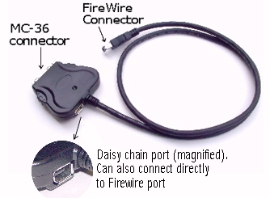
Picture 1

***Users can connect their Six Pin Firewire Cable
Into the Daisy Chain Port to use the Drive as well. ***
Power Source Installation

Backside view of the Drive
Power Option Switch
(PCMCIA/AC/DC) DC 5V input AC/DC jack

Audio Line Out MC-36 Pin Female Connector

Firewire CDRW Installation

For Win98SE and Win2000

(Note for Win98SE only: After plugging in the cable some system might prompt you for Win98SE CD, in case you don’t have The Win98SE CD and the wizard prompt you for
- NTMAP.SYS please type C:\WINDOWS\SYSTEM32\DRIVERS
- NTMAPHLP.PDR please type C:\WINDOWS\SYSTEM\IOSUBSYS
IF the system did not prompt you for anything just follow the steps below)

- Make sure the Firewire cable is securely attach from the back of the drive.
- When External power is attach to the drive make sure that the switch on the
Back of the drive is set to AC/DC.
- Power on the system, on the Window Desktop, double click on the
MY COMPUTER icon.
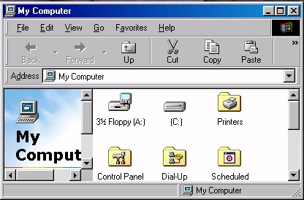

- Plug the FIREWIRE-IDE cable’s “FIREWIRE Connector” into
Your computer’s FIREWIRE port.
- Wait for a few seconds, your computer may blink for a moment as well.
- If all is well you should see another Drive Letter under my computer.
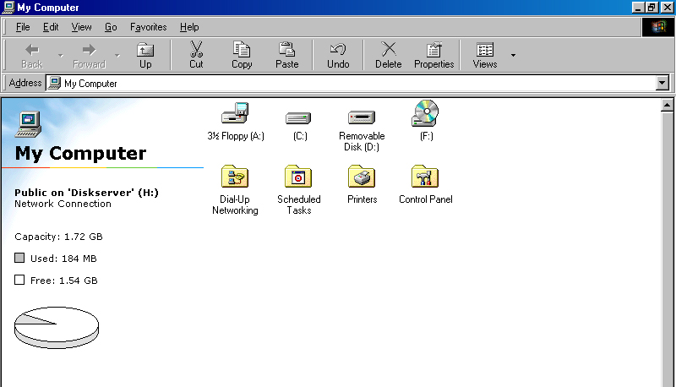

8. You may now access your Super Disk drive.

Technical Support

If you need assistance to get your unit functioning properly, please call Addonics Technical Support. Our technical staff will be happy to assist you, but they will need your help to do so. Calling the technical support staff without all the proper information can be both time consuming and frustrating. Here are some tips to help you out:

- MODEL NUMBER – Please have this number on hand.
(2) SYSTEM INFORMATION – Type of computer, peripherals, etc.
- OPERATING SYSTEM – What version of Windows
- WHAT’S THE TROUBLE? – Give enough information
About your problem so that we can recreate and diagnose it.

FREE Software Drivers for all Addonics Technologies
Products are available 24 hours per day at the
World Wide Web Site: www.addonics.com.

Contact Information

Addonics Technologies
48434 Milmont Drive
Fremont, CA 94538

Phone: 510-438-6530
Fax: 510-438-5236
Email: ATC@Addonics.com
Internet: http://www.addonics.com

TECHNICAL SUPPORT
Phone: 510-226-8579
Email: Techinfo@addonics.com

Please use our on-line registration card for your
Warranty registration.
Our web site is www.addonics.com

