February 2000
Prepared by Kieran McCorry
Applied Microsoft Technology Group
Compaq Computer Corporation

Contents
Introduction 3
Deployment Fundamentals 4
Interoperability and Coexistence 12
The Active Directory Connector 13
The Site Replication Service 28
The Active Directory Account Clean Up Wizard 33
Windows NT and Exchange Migration Scenarios 35

Moving to Exchange 2000
Abstract: This paper describes the process of moving to Exchange 2000. The process is multi-faceted, and this document therefore explores the techniques used when:
- Deploying Exchange for the first time at a Greenfield installation, where this is a new installation of Exchange 2000.
- Moving from legacy Exchange environments, such as Exchange 5.5, and seamlessly migrating users from the old system to the new.
Both processes require a sound understanding of some core Windows 2000 technologies and other fundamentals. It is the aim of this paper to discuss these technologies, their application to the challenge of moving to Exchange 2000, and to outline a process of moving to Exchange 2000 itself.

Notice
The information in this publication is subject to change without notice and is provided “AS IS” WITHOUT WARRANTY OF ANY KIND. THE ENTIRE RISK ARISING OUT OF THE USE OF THIS INFORMATION REMAINS WITH RECIPIENT. IN NO EVENT SHALL COMPAQ BE LIABLE FOR ANY DIRECT, CONSEQUENTIAL, INCIDENTAL, SPECIAL, PUNITIVE OR OTHER DAMAGES WHATSOEVER (INCLUDING WITHOUT LIMITATION, DAMAGES FOR LOSS OF BUSINESS PROFITS, BUSINESS INTERRUPTION OR LOSS OF BUSINESS INFORMATION), EVEN IF COMPAQ HAS BEEN ADVISED OF THE POSSIBILITY OF SUCH DAMAGES.
The limited warranties for Compaq products are exclusively set forth in the documentation accompanying such products. Nothing herein should be construed as constituting a further or additional warranty.
This publication does not constitute an endorsement of the product or products that were tested. The configuration or configurations tested or described may or may not be the only available solution. This test is not a determination of product quality or correctness, nor does it ensure compliance with any federal, state or local requirements.
Product names mentioned herein may be trademarks and/or registered trademarks of their respective companies.
Compaq, Contura, Deskpro, Fastart, Compaq Insight Manager, LTE, PageMarq, Systempro, Systempro/LT, ProLiant, TwinTray, ROMPaq, LicensePaq, QVision, SLT, ProLinea, SmartStart, NetFlex, DirectPlus, QuickFind, RemotePaq, BackPaq, TechPaq, SpeedPaq, QuickBack, PaqFax, Presario, SilentCool, CompaqCare (design), Aero, SmartStation, MiniStation, and PaqRap registered in United States Patent and Trademark Office.
Netelligent, Armada, Cruiser, Concerto, QuickChoice, ProSignia, Systempro/XL, Net1, LTE Elite, Vocalyst, PageMate, SoftPaq, FirstPaq, SolutionPaq, EasyPoint, EZ Help, MaxLight, MultiLock, QuickBlank, QuickLock, UltraView, Innovate logo, Wonder Tools logo in black/white and color, and Compaq PC Card Solution logo are trademarks and/or service marks of Compaq Computer Corporation.
Microsoft, Windows, Windows NT, Windows NT Server and Workstation, and Microsoft SQL Server for Windows NT are trademarks and/or registered trademarks of Microsoft Corporation.
NetWare and Novell are registered trademarks and intraNetWare, NDS, and Novell Directory Services are trademarks of Novell, Inc.
Pentium is a registered trademark of Intel Corporation.
NonStop registered in U.S. Patent and Trademark Office.
Copyright ©1999 Compaq Computer Corporation. All rights reserved. Printed in the U.S.A.

Thanks to Don Vickers, Kevin Laahs, Donald Livengood, Linda Gallacher, and Dung Hoang Khac for reviewing this document.

Comments to the author can be directed to Kieran.McCorry@compaq.com.

Introduction
Exchange 2000 is radically different from Exchange 5.5 or any of its predecessors. Architecturally, it’s a world away from the self-contained messaging system that was Exchange 5.5. Components that were built into Exchange 5.5 have now been separated from Exchange itself and, in most cases, integrated into the underlying operating system. For Exchange 2000, that operating system is Windows 2000.
Exchange 2000 positively requires Windows 2000 in order to operate. The Exchange 2000 executables themselves don’t run under any earlier versions, and to have an Exchange 2000 mailbox, you must have a Windows 2000 account. Why is there such a dependency? Well, there are a variety of reasons, but one of the most important reasons is the Active Directory.
Exchange 5.5 had a reliable and distributable built-in directory service. Now there is no directory service built into Exchange: Exchange 2000 relies completely on the Active Directory to store information about mailboxes, custom recipients, and distribution lists, although these Exchange 5.5 primitives are represented differently in Exchange 2000. Additionally, all of the configuration information about Exchange servers themselves that were previously held in the Configuration container of the Exchange 5.5 Directory Service, are now held in the Configuration naming context of the Active Directory. So what does all of this reshuffling mean? Basically, it means that Exchange 2000 has a huge dependency on the Active Directory. Subsequently, you must get the design of your Active Directory totally correct if you want your Exchange 2000 deployment to be successful. By implication then, this means that you must carefully plan and implement your whole Windows 2000 environment to provide a solid infrastructure for Exchange 2000.
Of course, all of that work merely provides a robust platform for a new Exchange 2000 deployment. But what of the work required to evolve your Exchange 5.5 environment through to the brave new world that is Exchange 2000? This is not just an upgrade of a few binaries; this is the re-engineering of a whole infrastructure. We’re presented with almost myriad challenges: providing mail coexistence between Exchange 5.5 and Exchange 2000; providing synchronization services between the Exchange 5.5 directory and the Active Directory; how to move Exchange 5.5 mailboxes to Exchange 2000 mailboxes. Of course, we haven’t even mentioned public folder infrastructures, business applications built on top of Exchange 5.5, and potentially other third party products that have been integrated into your Exchange environment. If that wasn’t enough, we also need to be concerned with the effort that’s required to upgrade the underlying infrastructure on which Exchange 2000 will run. In all likelihood, you’ll probably have NT4 deployed for account domains and resource domains for Exchange 5.5 servers: these domains will need to be upgraded to Windows 2000.
As you can see, moving up to Exchange 2000 isn’t just about upgrading a single software product: it’s about building a new infrastructure and doing it in a smooth and transparent way so that none of your existing users have an interruption to service. It’s not impossible to do, and in the remainder of this White Paper, we’ll explore the different tools and techniques that are critical for your successful deployment.

Deployment Fundamentals

Windows 2000 Refresher
There are some factors that are critical for any Exchange 2000 deployment to be successful (whether it is a Greenfield installation or a migration). Getting the Windows 2000 infrastructure right is a priority, so we need to make sure that we’ve got our Windows 2000 model soundly in place. Windows 2000 introduces many new phrases and terms, so as a refresher, let’s quickly review some Windows 2000 terms that we’ll meet again and again with respect to Exchange 2000.

Active Directory
The Active Directory (AD) replaces the flat-structured NT4 SAM with an X.500-like hierarchical directory structure. Exchange 2000 uses the Active Directory extensively because it no longer has a directory service of its own.

Active Directory Schema
The schema, amongst other things, defines the objects that can be stored in the AD. To store new object types, the schema must be modified to describe the structure of the new object, the attributes it may contain, where it may appear in the hierarchy, etc.

Windows 2000 Domain
A collection of Windows 2000 computers and user accounts that share a common security boundary. A Windows 2000 domain may contain Windows 2000 and NT4 computers as member servers or as Domain Controllers.

Windows 2000 Domain Controller
When a user needs authentication within a domain it contacts a Domain Controller (DC). You may have multiple DCs within a Domain and each DC holds a complete copy of the Domain Naming Context for the particular Domain in which it resides. This means that it knows about all other member servers, DCs, and users that are registered within that domain. A DC also holds a copy of the Configuration and Schema Naming Contexts for the whole Forest. DCs listen on LDAP port 389 for local domain queries.

Windows 2000 Forest
A Forest gets its name based on the name of the first domain that is installed. The name that you use for the first domain is very important since it potentially affects the naming structure for your whole organization. Many companies are using a placeholder first domain to allow them to build a forest and thus reserve a neutral name for it. Any DCs within the Forest share the same configuration and schema naming contexts. You can use the DCPROMO utility to join or leave domains in a Forest. A Forest is composed of a tree of domains; a tree of domains in the same branch holds a contiguous namespace.

Global Catalog Server
The Global Catalog (GC) server holds the same information as a DC. However, the GC also holds a read-only replica of every Domain Naming Context in the Forest. Thus, a DC only knows about the objects in its domain, while a GC knows about objects in its domain and every other domain. Although the GC knows about all objects from every domain, it only has knowledge of a subset of the attributes for each object. The objects that are available for replication to a GC are controlled by the AD Schema Manager snap-in. By default, the first DC in a domain is a GC. GCs listen on port 3268 (using LDAP) for queries as well as the standard LDAP port 389. A DC can be made into a GC by selecting the option from the AD Sites and Services snap-in.

FSMO
Flexible Single Master Operation. There are five different FSMO roles: Schema; Domain Naming; PDC emulator; RID; and Infrastructure. Only DCs can hold these roles. We’re only concerned with the Schema FSMO. Although Windows 2000 supports multi-master replication of data, some forms of replication are single-master because conflicts would be impossible to resolve in a last-writer-wins fashion. The Schema FSMO is unique in the Forest and it is responsible for making any modifications to the schema and distributing it to other DCs. When you first install Exchange 2000 you’ll need to make modifications to the schema. This is done on the Schema FSMO server.

Windows 2000 Site
Similar to the definition of a Site in Exchange 5.5 terms. A collection of IP subnets which are within an area of high speed network connectivity, such as a LAN. Sites may span domains, and accordingly, domains may span sites. There is no direct correlation between a Windows 2000 domain and a Windows 2000 site.

Exchange 2000 and Forests
Information about Exchange 2000 is rooted in the hierarchy of the Active Directory. In fact, information about your Exchange 2000 infrastructure is rooted in the Configuration Naming Context and because a naming context can’t span forests, it should be no surprise to learn that Exchange 2000 can’t span forests either. If you have multiple forests in your Exchange 2000 deployment, say one per geographical area, this means that you’ll end up with multiple Exchange 2000 organizations—essentially different Exchange 2000 implementations, so you need to plan for a homogeneous Windows 2000 infrastructure.
It’s also important to note that you can’t host multiple organizations within a single forest. While this may not seem too important—you want a single Exchange 2000 environment after all—it is important if you plan to implement a test environment. If you want a separate Exchange 2000 implementation for testing purposes then you’ll have to root this in a separate forest.
Although no such tools are available with the first release of Windows 2000 or Exchange 2000, you should expect to see forest management tools appearing with a subsequent release of Windows 2000, which will allow multiple forests to be merged together.

The Importance of Domain Controllers and Global Catalog Servers

User Authentication
In the world of Exchange 5.5, sites were created on the basis of good network connectivity. The parameters we looked for were reasonable available bandwidth (where reasonable varied anywhere from 32kbps to 128kbps) and low latency. Although the concepts of sites are no longer around with Exchange 2000, we do have the concept of a Windows 2000 site to deal with. Technically, of course, a Windows 2000 site is a collection of IP subnets, but in practice, that often means that good bandwidth and low latency connectivity is available.
From a pure Windows 2000 design perspective, it’s likely that Domain Controllers will be located close to groups of users. The reason for this is straightforward. When a user logs on to a domain, the logon process contacts the Domain Controller for that domain to validate the user’s credentials. Clearly, it makes sense to locate a Domain Controller close by for efficient logon performance. The logon process actually goes a little bit further than this, since logon requires not just access to a Domain Controller, but the Domain Controller actually requires access to a Global Catalog server. Although a Domain Controller can authenticate the credentials of a user in its domain, a user logon also requires a security token to be generated with details of every universal security group to which the user belongs. Of course, it’s possible that the user may belong to a security group in a different domain, and a local Domain Controller would have no knowledge of this “foreign” group. For this reason, the Domain Controller contacts a Global Catalog server to determine which groups the user belongs to so that access control can be correctly enforced.
So for every grouping of users, whether they are Exchange 2000 users or not, you should expect to see a Domain Controller and/or a Global Catalog server located logically close by.

Global Address List Services
As well as servicing user logon requests, Global Catalog servers offer directory lookup functionality to Exchange 2000 clients. Global Catalog servers hold a subset of the attributes from all objects within the forest, and specifically, for Exchange 2000, they hold name and address information. This means that Exchange clients use information from the Global Catalog server in the same way as the Exchange 5.5 Directory Service offered a Global Address List. Different types of clients use Domain Controllers and Global Catalog servers in different ways to get access to the Global Address List.

Exchange 2000
Global Catalog

Figure 1 Pre-Outlook 2000 Client accessing Global Catalog Server
MAPI clients earlier than Outlook 2000 always expect to find a directory service co-resident with the Exchange server to which they connect. In these circumstances, Exchange 2000 uses a mechanism called DS Proxy to establish a connection to the nearest Global Catalog server on the client’s behalf and transfers GAL-related communication between the client and the Global Catalog server. This is shown in . Depending on your deployment requirements, you may explicitly specify a particular Global Catalog server that should be used to handle DS Proxy activity. You can do this by setting the following value in the Registry:

HKEY_LOCAL_MACHINE\System\CurrentControlSet\Services\MSExchangeSA\Parameters
Value name: NSPI Target Server
Value type: STRING
Value data: <GC-server-name>

Outlook 2000 clients go one step further and instead of relying on the Exchange 2000 server to proxy access to a Global Catalog server on their behalf, Exchange 2000’s DS Referral mechanism is used. DS Referral is used by the Outlook 2000 client to make a direct connection to the nearest Global Catalog server. Upon connecting to the Exchange 2000 server, DS Referral updates the MAPI profile of the connecting client with details of the preferred Global Catalog server. Subsequent connections from the client are made directly to the Global Catalog server and the Exchange 2000 server takes no further part in communication between the client and the directory service. This communication process is shown in Figure 2.
Exchange 2000
Global Catalog

Figure 2 Outlook 2000 Client Accessing Global Catalog server

If you want to specify which GC should be used for DS Referral you can do so via the following registry setting:

HKEY_LOCAL_MACHINE\System\CurrentControlSet\Services\MSExchangeSA\Parameters
Value name: RFR Target Server
Value type: STRING
Value data: <GC-server-name>
You can also configure the Exchange Server not to give referrals, in which case Outlook 2000 clients will revert to using DS Proxy. This is achieved by setting the following registry setting:

HKEY_LOCAL_MACHINE\System\CurrentControlSet\Services\MSExchangeSA\Parameters
Value name: No RFR Service
Value type: DWORD
Value data: 0x1
You may want to consider doing this for two reasons. One is that, unlike DS Proxy, if the Global Catalog server disappears then the client will have to restart in order to pick up a new server for directory lookups. The second reason is that by using DS Proxy it is the Exchange server that is accessing the Global Catalog server and not the individual clients. If the GC were behind a firewall (which could be the case if you have remote sites with their own Exchange servers) then you could configure the firewall such that only requests coming from the Exchange server are let through.
Other clients, such as Outlook Web Access or Outlook Express make use of the Global Catalog server directly over LDAP and must be configured to point to a Global Catalog server directly.
Whatever way you look at it, there’s a huge dependency on intelligent placement of Domain Controllers and especially Global Catalog servers in order to provide an efficient infrastructure for Exchange 2000.

Choosing the Right Domain Model
With Windows NT4 and Exchange 5.5 there were many restrictions on the domain model that you could put in place. Typically, the restrictions related to the maximum number of account objects that you could place in a domain or to management capabilities across different groups of administrators with different management interests or objectives. Using Windows NT4 and Exchange 5.5 usually resulted in an environment with one or more Master User Domains and one or more Resource Domains for Exchange 5.5 servers in all but the simplest environments. (Similar to that shown in Figure 3.)
Master Domain
Trusts
Resource
Domain
Resource
Domain
Resource
Domain
Master Domain

Figure 3 Windows NT4 and Exchange 5.5 Domain Model
Using Windows 2000 we have an opportunity to build a more streamlined domain model either for new environments or to rationalize existing environments. Ideally, a single domain model is the target for which you should aim. The ability to streamline down to a single domain model using separate Organizational Units (where previously you may have used a resource domain) is a model that will be used by many organizations and becomes achievable with Windows 2000. Most importantly, because of the granular access controls, everything can be hosted in a single domain, yet administration can still be very finely tuned. (A preferred Windows 2000 domain model is shown in Figure 4.)
If you find yourself in a situation where you’ll be migrating a Windows NT4 domain environment to Windows 2000, it makes sense to restructure that domain environment, if it’s more than just a single domain. Rather than just upgrade existing systems, a more innovative approach is to build a new environment alongside the old Windows NT4 environment and then use migration tools to bring over Windows NT4 account information into the newly restructured domain. This approach is highly desirable because you get the opportunity to build a new streamlined environment and impact the existing user community as little as possible during the course of the migration, other than resetting all user passwords.
What you end up with is an optimized Windows 2000 environment that is ready for Exchange 2000.
Exchange 2000 Servers
User
Accounts
User
Accounts
Exchange 2000
Servers
Preferred Model
Acceptable Model

Figure 4 Possible Windows 2000 Domain Models

Preparing Windows 2000 Domains for Exchange 2000
Since Exchange 2000 has such a huge dependency on Windows 2000, it’s not surprising to learn that there are some explicit steps that you need to take to prepare the Windows 2000 environment for Exchange 2000.
Two command line options exist for the Exchange 2000 SETUP utility, which allow Administrators to prepare the environment. These options are collectively known as OrgPrep, but individually known as ForestPrep and DomainPrep.
Separating out these forest and domain preparation tasks from the Exchange 2000 installation process proper makes a good deal of sense in larger and more complex environments. Any sizable organization may have different teams of administrators that are responsible for pure Windows 2000 administration, and preparing the forest and domain infrastructure is essentially a Windows 2000 administration task that requires certain access rights. Allowing Windows 2000 administrators to do this means you have the right group of people performing that task, rather than having to elevate the access rights of messaging system administrators.

Running ForestPrep
You run the ForestPrep utility by executing the SETUP.EXE from the Exchange 2000 installation CD with the /FORESTPREP qualifier.
Running ForestPrep performs a number of important functions. Firstly it extends the Active Directory Schema to add new definitions used by Exchange 2000. Windows 2000 has about 1000 class definitions built into the Active Directory. These class definitions define, amongst other things, the hierarchy of objects and the attributes that may be associated with any given object. But, Exchange 2000 needs to reference more attributes than the standard ones provided in the base operating system definition. For example, Exchange 2000 needs to store extra information about your account, for example, the Exchange 2000 server on which your mailbox is located, which storage group your mailbox belongs to, etc.
To do this, the ForestPrep tool adds some additional auxiliary classes that augment the object class definitions that are already present for user, contact, and group objects. The class definitions are loaded into the Active Directory as a set of LDIF commands. You can see the files that contain the commands in the SETUP directory on your Exchange 2000 installation CD. They are named SCHEMA0.LDF, through SCHEMA9.LDF.
When running ForestPrep, you need to run it in the domain that holds the Schema FSMOr; typically the root domain. Although the Active Directory offers multi-master replication, modifications to the schema, the very fabric of the directory, can only take place on the Schema FSMO. If you have multiple domains in your Active Directory forest, you’ll want to be sure that the schema extensions have successfully replicated to all Domain Controllers within the forest. When the extensions are installed on the Schema FSMO, the schema version number will be incremented. You can check the value of the schema version number by looking at the following registry key:
HKEY_LOCAL_MACHINE/System/CurrentControlSet/NTDS/Parameters/Schema Version
or, by running the \SYSTEM32\SCHUPGR.EXE utility. If the schema version number is the same on the Schema FSMO and on another Domain Controller, then you can be confident that replication of the Schema Naming Context has taken place to at least that Domain Controller. It’s important that you check for replication having completed if you have multiple domains or Domain Controllers. If you try to install Exchange 2000, and the Domain Controller to which it connects doesn’t have the appropriate schema extensions in place, then the installation will terminate.
As well as populating the Active Directory Schema with new class definitions, ForestPrep does some other work. It creates the Exchange Organization object in the Configuration Naming Context and sets up the permissions structures, so you’ll be prompted for an Organization name that will be used for the new Exchange 2000 Organization. Clearly the work that’s carried out here requires the appropriate access rights, so you need to make sure that you are logged on to the domain with the appropriate privileges. You need to have Schema Admin privileges to make changes to the Active Directory schema, and you’ll also need Enterprise Admin privileges to create the configuration information.
If you intend to install an Exchange 2000 server into an existing Exchange 5.5 site, then you also need to have at least read-only rights to the Exchange 5.5 Directory Service. In this case, you won’t be prompted to enter the Organization name, but rather, you’ll be prompted to enter the name of an existing Exchange 5.5 server. ForestPrep will contact the Exchange 5.5 server and interrogate the Exchange 5.5 Directory Service to get organization and site naming information, which will then be configured into the Active Directory. ForestPrep also creates security groups for Exchange Servers and Exchange Admin groups.

Running DomainPrep
As well as running ForestPrep, which performs configuration required across the whole Active Directory environment, you will also need to run DomainPrep in every other domain where Exchange 2000 will be installed. It’s run the same way as ForestPrep; just execute SETUP.EXE from the Exchange 2000 installation CD with the /DOMAINPREP qualifier.
DomainPrep performs tasks such as creating the required global groups for Exchange 2000 Administration and Exchange 2000 service access to the Active Directory, and similarly, you’ll need to be logged on with Domain Admin privilege in order to run this utility.

How Do You Know If Your Schema Needs Upgrading?
If you take a look at the end of the SCHEMA9.LDF file, you’ll find an attribute called ms-Exch-Schema-Version-Pt. For example, with the build of Exchange 2000 that I’m using, Build 4208.2, the attribute settings in the file read:

dn: CN=ms-Exch-Schema-Version-Pt,<SchemaContainerDN>
changetype: modify
replace: rangeUpper
rangeUpper: 4197
During installation, Setup checks the value of this attribute in the SCHEMA9.LDF file against the actual value in the Active Directory, and determines whether or not the schema needs to be upgraded.
Obviously, you can also check the attribute settings to see the value of the Active Directory object’s attribute; this can be done using a tool such as ADSIEdit.

Best Practices You Should Observe When Preparing for Exchange 2000
Running the OrgPrep tools against your Active Directory infrastructure is not a task that should be performed without proper planning and preparation. You are making real changes to the very definition of the Active Directory, and as such, any such change should be properly evaluated. It makes a great deal of sense to establish a process of schema extension review (for the Exchange 2000 extensions and any other extensions you might make to tailor your Active Directory).
Furthermore, once the schema extensions have been applied to the Schema FSMO, don’t just rush off and try to install Exchange 2000 immediately. Give the Active Directory time to replicate the changes around your organization. Visit each Domain Controller (logically of course) and verify that replication has indeed taken place. Experience gained on other large scale Active Directory and Exchange 2000 deployments has always indicated the absolute importance of a functioning Active Directory replication infrastructure.

Installing Exchange 2000
Having prepared the way for Exchange 2000 using the OrgPrep tools, all that remains is to go ahead and install the software. Installation of Exchange 2000 uses a completely different User Interface, a sample of which is shown in Figure 5. The existing installation process is over eight years old and although it worked well with previous versions of Exchange, it is no longer suitable for use with a more complex installation process like Exchange 2000.
The new installation process uses a COM-based model for installing components, which offers a common look and feel across all of the BackOffice applications. (It should be noted that there is no support for MSI with Exchange 2000.)
The installation process is more or less consistent with other types of installations, specifically installing Exchange 2000 on a cluster. Although a cluster installation lays down essentially the same code, there are some cluster-specific files installed for cluster operation. In fact, an Exchange 2000 cluster uses its own resource DLL, which offers finer control for failover handling. All nodes in a cluster must receive Exchange 2000: you can’t just have a few nodes in the cluster running the software.
As well as an arguably improved user interface, the installation process offers improved support for unattended installations.
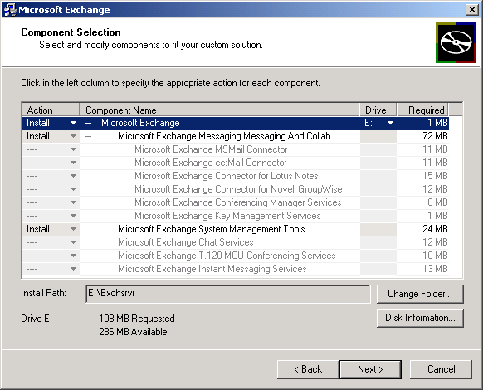

Figure 5 Exchange 2000 Installation User Interface
Unattended installations have much richer functionality than their Exchange 5.5 counterparts and make use of the /Q and /S installation options. These options provide Batch mode and Silent mode installation support, respectively. Batch mode allows an installation to take place without user intervention; answers to all questions (plus additional options) are provided in a standard Windows INI file.
You can use the Silent option with a Batch mode installation. When running the installation in Silent mode, all regular UI, any error messages, or user intervention dialogs are suppressed, and error information is written into the setup log file. If you perform a Silent installation, you must also perform the installation in Batch mode. However, just because you run a Batch mode installation, it does not mean that you must run in Silent mode.

Interoperability and Coexistence

What Requirements Do You Have?
Before you embark on any migration project, it’s important to understand the level of interoperability and coexistence requirements required in your environment
Coexistence means different things to different people. Basically, we have two points: a start point and an end point. The start point represents the Exchange 4.0/5.0/5.5 environment while the end point represents a pure Exchange 2000 environment. Ideally if we could move from the start point to the end point in an infinitesimally small period of time then the problem of coexistence approaches zero. However, the resources required to make such a journey are hard to come by, and in most cases some level of sustained coexistence is required.
An alternative exists of course. We can still make the move from start point to end point using some quanta of time, but ignore the problem of coexistence altogether. In real terms, this means that we begin a deployment of Exchange 2000 alongside a legacy Exchange environment, making no effort to:
- Allow new Exchange 2000 users to communicate with legacy Exchange users
- Move mailbox data from legacy Exchange servers to new Exchange 2000 servers
- Replicate public folders from legacy Exchange servers to Exchange 2000 servers
- Maintain group membership, distribution lists, or public folder access controls
- Maintain third-party product integration or business applications.
This is certainly the easiest migration to make because we have no coexistence factors to consider. However, it is unlikely that this scenario will be encountered very often. What’s more likely is that some form of coexistence will be required during a period of migration. Typically, this kind of coexistence takes the form of mail and directory interoperability coupled with a plan to migrate data from the legacy Exchange environment to the new Exchange 2000 environment.

Approaches To Coexistence
You can’t begin your migration to Exchange 2000 without fully understanding Windows 2000. The operating system infrastructure is required on two fronts: for the Exchange 2000 servers themselves; and for hosting user accounts—you can’t have an Exchange 2000 mailbox without a Windows 2000 user account.
Many different options exist for providing messaging connectivity. As we’ll see later, you can install Exchange 2000 servers alongside legacy Exchange servers so that they communicate using RPCs. Or, you can build a completely separate organization and communicate using X.400 Connectors or SMTP. Alternatively, you can use a combination of both and evolve your legacy Exchange environment to an Exchange 2000 environment.
As ever, directory synchronization provides the greatest challenge (and the most fun). If directory synchronization isn’t important to you, and you choose to go down a parallel path, you can populate your new environment initially from a one-off load of some description (you could get it from NT4 or Exchange 4.0/5.0/5.5).
Alternatively, and more conventionally, you can use a specialized tool—the Active Directory Connector—to provide ongoing synchronization between the Exchange 5.5 Directory and the Active Directory.
Having provided a sound coexistence environment, it’s imperative that the actions required to complete the migration, that is, to move user data from legacy Exchange to Exchange 2000, is easy.
If you choose to make a completely fresh start and not have an overlap between your legacy Exchange and Exchange 2000 environments, then this becomes more difficult. However, if you integrate the two environments more tightly, mailbox migration becomes relatively simple.

The Active Directory Connector

Overview
The Active Directory Connector (ADC) is one of the most powerful tools available to the messaging consultant. We know that Exchange 2000 doesn’t have its own built-in directory service. Instead it uses the Active Directory. During a migration exercise from legacy Exchange to Exchange 2000, one of the most important aspects of coexistence is that of synchronizing directory information between the Exchange 5.5 Directory Service and the Windows 2000 Active Directory. The ADC does just that: it maps the Exchange 5.5 Directory Service object types to the Active Directory and vice versa.

ADC Basic Operation
The ADC provides multi-master, bi-directional synchronization of data between the Exchange 5.5 Directory Service and the Active Directory using the LDAP protocol. ADC synchronization can take place uni-directionally, if required. The ADC operation is based on the replication model that the Exchange 5.5 Directory Service uses, but while the Exchange Directory Service uses object-level replication, the Active Directory use attribute-level replication. The ADC sits in between these two models and arbitrates the transfer of the minimum amount of information, while synchronizing data.
Exchange 5.5 Directory Service object replication works using Unique Sequence Numbers (USNs), which are associated with every object. When an object is changed, its USN is updated and this change in the USN indicates that a local copy of the object requires updating. The ADC replication engine is loosely based on this USN model.
The ADC runs on the Windows 2000 server and its installation process will update the Active Directory schema if an Exchange 2000 installation has not already added its schema extensions. The extensions that the ADC puts in place for its operation only represent a subset of the Exchange 2000 schema extensions, so if you subsequently install Exchange 2000, you find that still some more extensions need to be added.
Essentially, an instance of synchronization, known as a Connection Agreement (CA), runs on the ADC and points to both directory services at the same time. (You can see an example of these Connection Agreements and how they are represented within the ADC in Figure 6.) One half of a CA points to a Windows 2000 Domain Controller or Global Catalog server, while the other half points to an Exchange 5.5 SP3 Directory Service running the LDAP protocol.
Two versions of the ADC are available: one that ships on the Windows 2000 installation CD and one that ships on the Exchange 2000 installation CD. The Windows 2000 ADC only synchronizes information from the Exchange Directory Service Site naming context, while the Exchange 2000 ADC synchronizes information from the Exchange Directory Service Configuration naming context as well. What does this mean? Well, it means that the Windows 2000 ADC only deals with synchronizing user information, while the Exchange 2000 ADC also synchronizes legacy Exchange server information. Although you can use the Windows 2000 ADC to populate the Active Directory with Exchange 5.5 recipient information, you should make sure that you’re using the Exchange 2000 ADC before you begin to upgrade or install Exchange 2000 servers into your legacy Exchange environment.
How can you tell which version of the ADC that you’re running? Simple: just check the version number of the ADC executable. The version number of ADC.EXE supplied with Windows 2000 RTM is 6.0.3939.7, whereas the version number of the ADC that comes from the Exchange 2000 will be later. In the case of the version just before RC1, it should read 6.0.4208, but obviously any version that you have might be different.

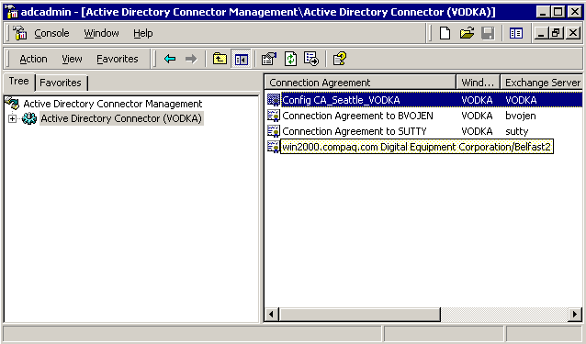

Figure 6 Active Directory Connector Hosting Four Connection Agreements

Using Connection Agreements

The Relationship between Active Directory Connectors and Connection Agreements
As shown in Figure 6, you can use the ADC Admin MMC snap-in to create and manage Connection Agreements between the two directory services. You can host multiple CAs on a single ADC and for the most simple environments you can get away with using just a single CA to map information between a container tree in the Exchange 5.5 Directory and an Organizational Unit object in the Active Directory. For a more complex interchange of directory information, you may require multiple CAs. We’ll discuss these situations below.
There are no architectural limits on the number of CAs that you can host on a single ADC, but popular opinion suggests a practical upper limit of about 75 CAs per ADC from a performance perspective.
Depending on the complexity and geographical distribution of your environment, you may decide to use just one ADC hosting multiple CAs, or you may decide to deploy an ADC in major geographical regions around the globe. For example, one in the Americas, one in Europe, and one in Asia Pacific. From a directory synchronization standpoint, it’s easier to conceptualize synchronization if you centralize all synchronization activity to just one location. The downside of this is that directory replication latency comes into play, and as synchronization takes place between the directories in the central location, you have to wait for the Exchange 5.5 Directory Service replication interval and the Active Directory replication schedules to begin before you can be sure that the updated objects have been distributed across your organization.
Distributing ADCs implies that you will use a set of CAs per ADC, which will synchronize Exchange 5.5 containers and Active Directory Organizational Units close to you in a timely fashion. While you can have multiple CAs synchronizing the same set of objects (more about this later) it’s best if you tolerate or optimize your directory replication settings rather than introducing more complexity into the synchronization environment.

Configuration Connection Agreements
So far when we’ve talked about CAs we’ve really been concerned with the synchronization of recipient container information between the Exchange 5.5 Directory Service and the Active Directory. However, there is also a special type of CA known as the Configuration Connection Agreement (CCA), to consider.
As well as synchronizing recipient information, cooperation between Exchange 5.5 and Exchange 2000 servers means that configuration information must also be exchanged. Information from the Exchange 5.5 Directory Service Configuration Container is synchronized into the Configuration Naming Context of the Active Directory using a CCA. CCAs are created automatically when an Exchange 5.5 server is upgraded to Exchange 2000, or when an Exchange 2000 server is installed into an Exchange 5.5 site, so there’s no manual intervention required to set them up.

How Many Connection Agreements Do I Need?
In the simplest cases, all you need is one bi -directional CA to replicate one or more legacy Exchange Recipient containers to a single Active Directory OU, and one or more Active Directory OUs to a single Exchange container. Look at the example in Figure 7.
ADC server
Exchange 5.5
Sites
Windows 2000
Active Directory
DR
Connectors
Connection
Agreement

Figure 7 Multiple Exchange 5.5 Sites with a Single Connection Agreement
The objects contained in the Active Directory OUs are mapped to a single container on the target Exchange 5.5 server, and then the standard legacy Exchange directory replication model allows this container to be seen across all legacy Exchange sites. Similarly, any number of legacy Exchange containers can be mapped to single Active Directory OU that is replicated across the forest using the standard Active Directory replication model.
In more complex scenarios, a single CA is not sufficient. Fundamentally, there are two frameworks where multiple CAs are required.
Because legacy Exchange mailboxes may be synchronized to the Active Directory, you can use Active Directory Management tools, such as the Active Directory Users and Computers MMC snap-in to manage legacy Exchange mailboxes. Managing legacy mailboxes from the Active Directory means that you’ll need to have a separate CA back to the Recipients container for the legacy Exchange site in which the mailbox is located. In the Exchange 5.5 Directory Service, objects outside the site in which they are located are read-only, so a single CA to an arbitrary legacy Exchange site is not sufficient to allow write access to an object. Hence, in this scenario, one CA per legacy Exchange site is required.
You can see an example of such a CA arrangement in Figure 8.
ADC server
Exchange 5.5
Sites
Windows 2000
Active Directory
DR
Connectors
Connection
Agreement

Figure 8 Multiple Exchange 5.5 Sites with a per Site Connection Agreement Arrangement
In terms of best practice, Compaq strongly suggests using like to manage like. This means that you should, if possible, use the Exchange 5.5 Administrator program to manage legacy Exchange objects and the Active Directory Users and Computers snap-in to manage Exchange 2000 objects. In fact, the Exchange 2000 installation menu allows you to install the Exchange 5.5 Administrator expressly for this purpose.
The other framework in which multiple CAs are required relates to many-to-many mappings. In general, a single CA allows one-to-one and many-to-one mappings of legacy Exchange containers to Active Directory OUs, and vice versa. Many-to-one mappings are realized in two ways: first of all you select multiple containers on the same level at the source; and secondly, container hierarchy is honored from the source. If you need to make many-to-many mappings, then a single CA is not sufficient since only one target container or OU can be specified on the CA. In this case, you’ll need to use a separate CA for each target container or OU, as shown in .

Single Container
To Single OU
Single CA
Multiple Containers
To Single OU
Single CA
Multiple Containers
To Multiple OUs
Multiple CAs

Figure 9 Mapping Arrangements for Legacy Exchange Containers
When might you want to do this? Well let’s say you wanted to map users from three different legacy Exchange sites, say Dublin, Paris, and New York across to three different OUs, again called Dublin, Paris, and New York. You’d need three separate CAs to perform this type of mapping.

Connection Agreement Connections
For a CA to read or write object information from either the legacy Exchange Directory Service or the Active Directory, it must make an authenticated connection to both directory services over LDAP. You can specify the credentials that you will use for the connection on the Connection Properties tab as shown in Figure 10.
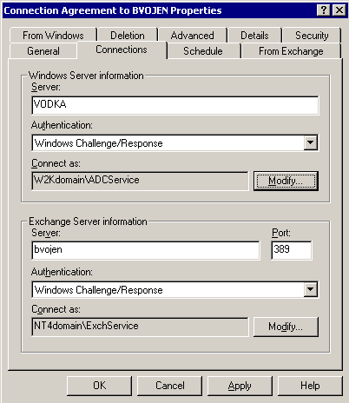

Figure 10 Connection Properties Tab
You should think carefully about the accounts that you use to access the directory services. The accounts specified must have the appropriate read and/or write access to the respective directory containers or OUs that you specify. It’s inadvisable to use an Administrator account for something like this. It suffers from the same restrictions that you would have come across if you tried to use the Administrator account as the Site Services Account in the Exchange 5.5 world: that is, changing the Administrator password and then finding out later that services fail to start after the next reboot. In the same way, you’d expect to see ADC synchronization fail to operate and the cause may not be immediately obvious. So, for this reason alone, it makes more sense to separate authentication functionality and use a dedicated account. Perhaps the Exchange Site Services Account when connecting to the Exchange 5.5 Directory Service, and, since there’s no Site Services Account used in the Exchange 2000 world, a dedicated account, which in the example shown in Figure 10, is the ADCService account.
It’s also important to note that you can specify the port number for the connection to the legacy Exchange Directory Service. Connections to the Active Directory always take place against a Global Catalog server on port 3268, but on both the Global Catalog server and the Windows 2000 Domain Controller, port 389 is also used for general domain scope LDAP queries. If you’re running Exchange 5.5 on a Windows 2000 Domain Controller and you have enabled the LDAP protocol from within the Exchange 5.5 Directory Service, then it can’t use port 389 because it has already been allocated to Windows 2000. In this case, you need to modify the port from the Exchange 5.5 Protocol settings so that a different port number is used to offer LDAP access to the Exchange 5.5 Directory. It’s common to change the port number to 390 as it is not used by any other applications, but remember to then modify the port to connect to in the Connections tab.

Selecting The Appropriate Schedule
Getting the scheduling of your CAs right is quite important. You should arrange to have CA synchronization take place after you perform any moves or updates to objects in either directory. So, if you intend to migrate users from legacy Exchange to Exchange 2000 overnight, you should be sure to run the CA immediately after these moves have taken place. You can use the Selected Times option to do this. See Figure 11.
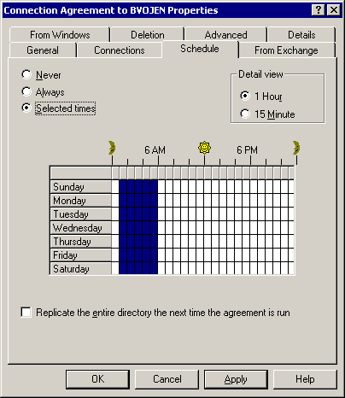

Figure 11 Using the Schedule Property Tab
If you are moving user accounts generally at any time, then you’ll probably want to set the schedule to Always. Setting the replication interval to Always actually means every six or seven seconds, whereas with Exchange 5.5, setting a schedule interval to Always typically meant every 15 minutes. Setting too aggressive a schedule may result in unexpected work on the target servers. ADC LDAP operations are costly since every time a synchronization is required, an LDAP search is performed on the container hierarchy that you’ve specified in the CA to detect changes. Clearly this takes place for both sides of the CA. If you have a large number of sites or OUs to traverse, then that load may be intensive. It is wise to avoid setting an Always schedule in such cases.
If you do decide to set the synchronization schedule to Always, you can control the delay between synchronization cycles by modifying the following registry setting:

HKEY_LOCAL_MACHINE\System\CurrentControlSet\Services\MSADC\Parameters
Value name: Synch Sleep Delay
Value type: DWORD
Value data: <number of seconds to wait between cycles>
You’ll notice another box on the Properties Tab in Figure 11: Replicate the entire directory the next time the agreement is run. Ordinarily, a full replication only takes place the first time that the CA is executed. Checking this box forces all directory objects to be checked for consistency and if there are any discrepancies between the directories, objects will be replaced. If objects are found to be consistent, they will not be replicated.
Checking this box sets the following Active Directory object attributes:

MsExchServerXHighestUSN to 0
MsExchDoFullReplication to TRUE

Synchronizing Objects From Exchange 5.5

The From Exchange Tab
You define the object types that you want to synchronize from the Exchange 5.5 Directory Service by checking the appropriate types, and the source containers that you’ll synchronize from. See Figure 12.
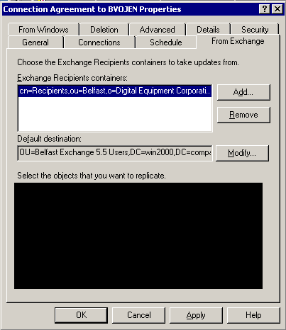
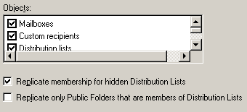

Figure 12 Using the From Exchange Property Tab
Multiple Exchange 5.5 containers can be selected and they will synchronize on a many-to-one mapping to a single Active Directory OU. Additionally, you can be selective about the object types that you’ll synchronize with a particular CA. You may decide to select only mailboxes, or custom recipients, or distribution lists, or public folder addresses for each CA. The objects you select determines what gets synchronized into the Active Directory.

Exchange to Active Directory Attribute Mapping for Mailboxes and Custom Recipients
The ADC behaves differently depending on the type of Exchange 5.5 mailboxes and Windows NT4 objects that you are synchronizing.
A Windows NT4 account and an Exchange 5.5 mailbox can be mapped to either a mail-enabled contact, a mailbox-enabled user, or a disabled mailbox-enabled user. You decide whether objects should be mapped to contacts or user objects, but typically the migration process is much simpler if mappings are made to either live or disabled users. However, if you’ve already migrated the Windows NT4 account over to Windows 2000, then the mapping behavior is different. A Windows 2000 account and an Exchange 5.5 mailbox always get mapped across to a mailbox-enabled user in the Active Directory. What’s the difference between these two mail-enabled and mailbox-enabled object types?
Firstly, we need to understand the difference between mail-enabled and mailbox-enabled objects. Mail-enabled objects are those users that have an associated Mail-recipient auxiliary class. This means such objects are capable of having email directed to them because they have an associated email address. Mailbox-enabled objects are a special case of mail-enabled objects because they not only have the Mail-recipient class, but they also have an associated Mail-storage class. Mailbox-enabled objects always have an Exchange mailbox associated with their account.
With the combination of a Windows 2000 account and an Exchange 5.5 mailbox, some attributes on the Active Directory user object are set which, ordinarily, wouldn’t be set with an NT4 account synchronized object. Specifically, the msExchHomeServerName is set (see Figure 13) and references the Exchange 5.5 server on which the mailbox is located.
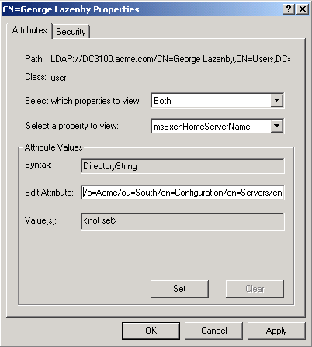

Figure 13 Using ADSIEdit to View values of a Mailbox-enabled ADC-synchronized User
Simpler mapping rules apply for Exchange 5.5 custom recipients; these always get mapped to Mail-enabled contacts.

Exchange to Active Directory Attribute Mapping for Distribution Lists
Mapping Exchange 5.5 distribution lists across to corresponding primitive objects in Windows 2000 distribution groups, is more complicated than it might seem. By default, the ADC will always map an Exchange 5.5 Distribution List across to a Universal Distribution Group (UDG) in the Active Directory. Let’s take a moment to refresh our memories on the different types of group scope that you might encounter:
- Domain Local Groups can have membership from anywhere in the forest, but the group only has local domain scope
- Domain Global Groups can only have membership drawn from the local domain, but the group has global scope
- Universal Groups can have membership drawn from anywhere in the forest, and the group has global use
UDGs have the membership and scope that Exchange 2000 requires, and they can exist in mixed mode domains. For the purposes of mail distribution, these groups work very well.
However, many Exchange 5.5 installations use distribution lists for more than just mail expansion. Specifically, where Public Folders are used, it’s not uncommon to find users bundled into distribution lists that have public folder ACLs put in place using distribution list. In Windows 2000, ACLs cannot be used with any form of Distribution Group.

Using Universal Security Groups to Enforce Exchange 2000 Public Folder Permissions
While UDGs can’t be used to enforce access controls in Windows 2000, Universal Security Groups (USGs) can be, and in fact, must be used if you want to use a group of any kind to set ACLs on an Exchange 2000 Public Folder hierarchy.
There are some characteristics of USGs that are of concern to us with respect to Exchange 5.5 interoperability. USGs can only exist in native mode Windows 2000 domains, but they can contain members that exist in mixed mode domains.
Although the ADC will never create USGs, it will always create UDGs, which, if they are in a native mode domain, may get converted to USGs at a later stage by one of several methods. For this reason alone, you can see the importance of getting Windows 2000 native mode domains in place as soon as possible.

Universal Security Groups and Mixed Mode Membership
Ideally, all of your domains should be in native mode before you start to deploy or migrate to Exchange 2000. However, there is no explicit requirement for this to be the case. And in the scenario where you have USGs in native mode domains we’ve already mentioned that there is no requirement that the membership be drawn from other native mode domains. This flexibility is useful because it means that there’s no restriction placed on the domain mode before you start to implement Exchange 2000. Having said that, Compaq’s best practice recommendations state that you should complete the migration to Windows 2000 account domains before you begin to deploy Exchange 2000. In doing so, those account domains should be in native mode.
Remember that when a user logs into a domain, the GC is consulted so that the SIDs of any universal groups to which the user belongs is built into the user’s security token. However, if the user is a member of a mixed mode domain , then those SIDs are not placed into the token.
So clearly there is a problem, in so far as a user can be a member of a USG and you can use the USG to permission Public Folders, but those permissions will not be adhered to if the user account is located in a mixed mode domain and the user requests access from the Public Folder. At best, if the USG has been used to identify those users who have access to the Public Folder, this will result in the user not being granted access. However, in the worst case, if USGs have been used to enforce explicit deny access, then there is the possibility that users may get access to Public Folder information which, ordinarily, they should not be able to access.

Token Augmentation
Obviously, it’s not appropriate to allow such a gaping hole in the Public Folder permissions model to exist in a production environment, so a technique called Token Augmentation is used to plug the gap.
The problem only exists if a user’s account is located on a server in a mixed mode domain. (User accounts located in native mode domains that are members of a USG are not affected.) Windows 2000 provides a function that allows an application, Exchange 2000 in this case, to discover which USGs a user is a member of. Exchange 2000 then add the SIDs of those USGs into the user’s token. This results in an augmented token, which is used in subsequent access checks. This new function wasn’t part of Windows 2000 RTM, but is available in a post-RTM hotfix and is bundled in Service Pack 1.
In this way, Exchange 2000 offers the same functionality that you would expect to get with a native mode domain, although the user’s domain is actually in mixed mode, with the complete token being built not at login time, but deferred until later when the user tries to access the Exchange resource. Note that the token is only augmented on demand; that is, when the user requests access to an object with permissions set. When access is requested, Exchange 2000 only invokes the Augmentation code if the forest in which the domains are located is not wholly in native mode. Exchange 2000 can determine if the user is from a mixed or a native mode domain, and the token is augmented once and then cached on the server that is attempting access.
Token augmentation becomes more complex when you have to deal with trust relationships to Windows NT4 domains and to other Windows 2000 domains in different forests:
- Trust relationships to Windows NT4 domains may use the ADC to create disabled user accounts in the new Windows 2000 domain and then assign mailbox rights back to that trusted Windows NT4 account. Since we are using a trusted Windows NT4 account, the token that is generated at logon time is based on the Windows NT4 account, yet the USGs will be based on the disabled user object. In this case, Windows 2000 provides another set of function calls that allows Exchange 2000 to update the Windows NT4 token.
- Trust relationships to domains in another forest use a special switch, setting msExchAddGroupsToToken to TRUE, to achieve the same objective.
Token augmentation is only implemented for certain client protocols, specifically, MAPI, HTTP/DAV, and OLE-DB. However, it is not available for ExIFS, IMAP, NNTP, or POP3, so the user experience may vary depending on the client that you’re using at any particular time.

Converting Universal Distribution Groups to Universal Security Groups
The ADC never creates USGs, only UDGs, so there must be a process that will convert UDGs to USGs. This process is carried out by Exchange 2000 itself and under three different circumstances:
- During an Upgrade when a Public Folder store is upgraded from Exchange 5.5 to Exchange 2000
- When a Public Folder is replicated from an Exchange 5.5 server to an Exchange 2000 server
- When an Outlook client assigns Public Folder rights on an Exchange 2000 Public Folder, for example, giving a distribution list read permissions to a Public Folder
Of course, this conversion process only takes place if the UDG already exists in a native mode domain. If the UDG is in a mixed mode domain, then no conversion takes place. Similarly, only those UDGs that are used to permission Public Folders are converted to USGs; any other UDGs used simply for mail expansion are ignored during the conversion process.

Dealing With Hidden Distribution Lists
To reduce the possible adverse effects of replicating membership of hidden distribution lists from Exchange 5.5 servers to Windows 2000 servers, the ADC does not replicate membership for hidden distribution lists, by default.
In legacy Exchange versions, there is an option to hide the membership from the Address Book for distribution lists. When this option is selected, a user cannot view the members of a distribution list in the Address Book. However, mail sent to this distribution list is still delivered to all of its members. When the ADC replicates this distribution list to Windows 2000 as a Distribution Group, the Active Directory is unable to enforce this rule and this subsequently represents a security risk.
Leaving the Replicate membership for Hidden Distribution Lists option (as shown in Figure 12) set with the default value, unchecked, causes the Distribution Lists that are replicated to display containing no members. Consequently, when mail is sent to this Distribution Group by an Exchange 2000 user, the mail is not delivered to anyone. Although membership display integrity is maintained, the functionality of the Distribution Group becomes questionable!
If you do not check this option, your Distribution Groups will remain secure, but mail is not delivered to the members. A summary of what you can expect to see is shown in Figure 14.

5.5 DL Settings | Replicate Unchecked | Replicate Checked
GAL Visible, Membership Visible | Address Book Visible, Membership Visible | Address Book Visible, Membership Visible
GAL Visible, Membership Hidden | Address Book Visible, Membership Hidden | Address Book Visible, Membership Visible
GAL Hidden, Membership Visible | Address Book Hidden, Membership Visible | Address Book Hidden, Membership Visible
GAL Hidden, Membership Hidden | Address Book Hidden, Membership Hidden | Address Book Hidden, Membership Visible
Figure 14 Distribution List Mapping Behavior

Distribution Lists and Synchronization Latency
Under certain circumstances, you may find that Exchange 5.5 Distribution List objects can be synchronized before the discrete objects that make up their membership are synchronized.
For example, you may find that you are using one Connection Agreement to synchronize a distribution list that’s newly created, and the schedule for this has it running before another Connection Agreement that is used to synchronize mailbox objects. If the distribution list had membership objects that referenced objects that were not yet created in the Active Directory, then the Distribution Group could not populate its membership for those phantom objects. This is a referential integrity feature of the Active Directory.
In this case, and if no other precautions were in place, when the Connection Agreement that controls synchronization in the reverse direction runs later, there is a risk that this partial Active Directory Distribution Group would force the original Exchange 5.5 Distribution List to have its membership altered, thus removing perfectly good membership information.
However, the ADC and the Active Directory avoid this problem by using a special attribute called unmergedAtts. During the first synchronization run, if objects can’t be added to the Active Distribution Group because the those membership objects don’t yet exist, they’re added to the unmergedAtts attribute, and this attribute is used on the subsequent back-synchronization to ensure that no membership information is lost.

Attribute Mapping Mechanism
Using an Exchange 5.5 mailbox as an example, the following steps would be taken as objects are synchronized from Exchange 5.5 to the Active Directory:
- Exchange 5.5 uses the Distinguished Name (DN) of an object as its unique key.
- Objects replicated to the Active Directory have the DN stored in legacyExchangeDN.
- Objects replicated to Exchange have the NT Global Unique ID (GUID) stored in them.
- The ADC attempts to retrieve the DN, NT GUID, and PrimaryNTAccount (SID) from the Exchange object.
- If the NTGUID exists and a corresponding GUID is found in the Active Directory, the object is selected from the Active Directory and the attributes are merged. As part of the merge, the legacyExchangeDN is also updated.
- If the NTGUID isn’t present, the Active Directory is searched using the object’s DN, which is matched against the legacyExchangeDN . If a match is found, a merge takes place.
- If the legacyExchangeDN doesn’t match, then a search is performed against the Active Directory using the sIDHistory. If a match is found, the object is updated if the legacyExchangeDN matches or is empty.
- If no match is found, then there is no account to compare, and a new object is created in the Active Directory as defined in the Connection Agreement.

Synchronizing Objects from Active Directory

The From Active Directory Tab
In the same way as you can specify which containers you want to synchronize from the Exchange 5.5 Directory Service, you can use the From Active Directory Tab to specify which OUs you want to synchronize from the Active Directory to a specific Exchange 5.5 Directory Service container. Figure 15 shows the properties that define how synchronization takes place.
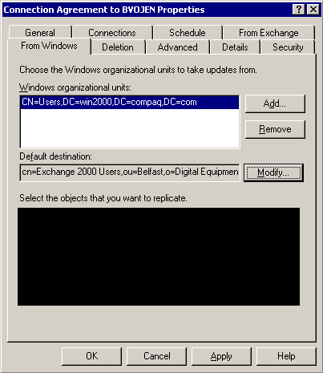
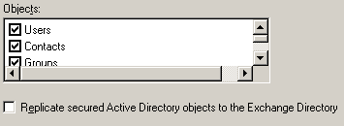

Figure 15 Using the From Active Directory Property Tab
Multiple Active Directory OUs can be selected and synchronized on a many-to-one mapping to a single Exchange 5.5 Container. Additionally, you can be selective about the object types that you want to include in the Connection Agreement.
The mapping rules are generally simpler for Active Directory to Exchange 5.5 Directory Service synchronization. Exchange 2000 mailbox-enabled users are mapped back to Exchange 5.5 mailboxes, while contacts are mapped back to Exchange 5.5 custom recipients. Mail-enabled groups, both distribution and security, are mapped back to Exchange 5.5 Distribution Lists. Non mail-enabled users, contacts, or groups are not synchronized at all.
By default, hidden objects in the Active Directory are always synchronized as hidden objects to the Exchange 5.5 Directory Service, but membership of Distribution or Security Groups is always exposed. Similarly, secured Active Directory objects have an entry containing a deny permission on the Security tab of the object. There is no explicit default attribute mapping for the deny permission, so when synchronizing objects to the Exchange 5.5 Directory Service, a dedicated check box (as shown in Figure 15) is used to ensure that secured objects are not dropped during synchronization.

Attribute Mapping Mechanism
Using an Exchange 2000 mailbox-enabled user as an example, the following steps are taken when objects are synchronized from the Active Directory to Exchange 5.5:
- Mail-enabled or mailbox-enabled objects only are synchronized to Exchange 5.5.
- The Active Directory holds a Distinguished Name (DN), but objects are keyed on a GUID.
- Objects replicated to Exchange 5.5 have their GUID stored in the Exchange Directory object.
- Objects replicated to Active Directory have their DN stored in the legacyExchangeDN attribute.
- The ADC attempts to retrieve the DN, GUID, and SID from the Active Directory object.
- A search is performed against the Exchange Directory for an object with a matching GUID. If found, the object is retrieved and the attributes are merged.
- If no match is found, and the legacyExchangeDN attribute is present on the Active Directory object. A search is performed against the Exchange Directory to find an object with a matching DN. If a match is found, but the GUID is different from the Active Directory object’s GUID, the Exchange Directory object is overwritten and the attributes are merged.
- If no match is found and the SID attribute is present in the Active Directory object, then the Exchange Directory is searched for an object with a matching SID. If a match is found, the attributes are merged.
- If no match is found an object is created in the Exchange Directory.

Advanced Connection Agreement Properties

Primary Connection Agreements
Connection Agreements can be primary or non-primary. Primary CAs can create objects in the target container or OU, while non-primary CAs may only modify an existing object in the target. You should have only one Primary CA for any given group of recipients, although you may have non-primary CAs to those destinations, especially if you have a large environment and you want to put overlapping CAs in place to ensure minimal synchronization latency.
Setting the Primary Connection Agreement flag on more than one CA should only be done if different object classes are synchronized by each CA, or if you’re mapping to multiple Active Directory domains. Incorrectly using this setting will result in duplicate objects in the target directory. Those primary or non-primary CAs can be either in the direction of Exchange 5.5, or the Active Directory, or both. You can see the settings in Figure 16.
As a matter of Best Practice it’s much better to have a single point of synchronization and have your Exchange 5.5 Directory Service and Active Directory replication schedules set to minimize latency.
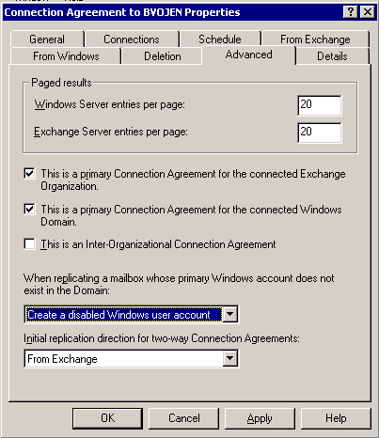

Figure 16 Connection Agreement Advanced Properties Tab

Inter-Organizational Connection Agreements
You’ll notice a check box in Figure 16, which reads This is an Inter-Organizational Connection Agreement. Setting this option essentially turns the CA into a general-purpose synchronization tool between two different Exchange 5.5 and Exchange 2000 organizations. That is, the organization names for the Exchange environments are different.
When you check this box, the CA is prevented from creating mailbox-enabled users in the Active Directory: Exchange 5.5 mailboxes are represented as mail-enabled contacts in the Active Directory and similarly, in the Exchange 5.5 Directory Service. Custom recipients are always created for Exchange 2000 mailbox-enabled users.
Custom recipients, contacts, distribution lists, and distribution and security groups are also supported over an inter-organizational CA, but the synchronization behavior is more in line with what you’d expect in a classic directory synchronization environment.

The Site Replication Service

Overview
The Site Replication Service (SRS) pretends to be an Exchange 5.5 Directory Service but runs on an Exchange 2000 server. While the ADC actually provides a mechanism to perform directory synchronization between the Exchange 5.5 Directory Service and the Active Directory, the SRS acts as a shadow Exchange 5.5 Directory on an Exchange 2000 server and provides mail-based replication services.
However, you don’t have the SRS running on each and every Exchange 2000 server. While it is installed by default, it is only configured under certain circumstances:
- When the first Exchange 5.5 server is upgraded to Exchange 2000 in an Exchange 5.5 site
- When the first Exchange 2000 server is installed into an Exchange 5.5 site
- When an Exchange 5.5 Bridgehead server is upgraded to Exchange 2000
The SRS does not act as an alternative means for exchanging either recipient or configuration information between Exchange 5.5 servers and Active Directory servers. Only the ADC provides this functionality, and all the SRS does is to take part in Exchange 5.5 Directory replication and sustain a local copy of the Exchange 5.5 directory. Having a local copy of the directory does not of course imply that anything is done with this information. However, the guaranteed presence of an Exchange 5.5 Directory database on an SRS-enabled Exchange 2000 server does have its benefits.
In the example scenarios that follows, I’ve used CCAs as an example of the Connection Agreements that are important for use with the SRS. Of course, it’s not just configuration information that gets replicated with Exchange 5.5, but recipient information as well. In the interests of simplicity, I haven’t included recipient-type CAs in the examples, but these are nonetheless involved in the SRS behavior.

What is the SRS Composed Of?

SRS Components
The SRS consists of three major components:
- A lightweight Exchange 5.5 Directory Service with a replication engine
- The Knowledge Consistency Checker (KCC) from Exchange 5.5
- The Super Knowledge Consistency Checker (SKCC), which is a new piece of code that understands the Active Directory configuration and legacy Exchange site topology, and controls the ADC and the Exchange 5.5 replication mechanism by tweaking the Configuration Connection Agreements and Directory Replication Connectors

SRS Files
The SRS is realized by a set of files that provide directory replication functionality between Exchange 5.5 and an SRS database on an Exchange 2000 server. You’ll find the following files available:
- SRS.EXE which provides the main Exchange 5.5 Directory Service look-alike code and other functions;
- SRSCHECK.DLL which provides directory replication consistency checking
- SRSMAPI.DLL which provides directory replication mail services
- SRSPERF.DLL which provides performance counters
- SRSMSG.DLL which provides event logging functionality
- SRSXDS.DLL which provides the SRS XDS API
- SRS.EDB which provides the DSA database file (the file formerly known as DIR.EDB)
These files all provide the SRS service that runs with the key MSExchangeSRS under the display name, Microsoft Exchange Site Replication Service.

SRS Intra-Site Replication Operation
When an Exchange 2000 server appears in an Exchange 5.5 site, the SRS is enabled, as shown in Figure 17.
5.5 Site
ADC
CCA
S
R
S
5.5
5.5
5.5
5.5
2000
(SRS)

Figure 17 A Single SRS-enabled Server in an Exchange 5.5 Site
This means that the Exchange 2000 server’s SRS has a means to communicate with other Exchange 5.5 servers using the normal intra-site replication mechanism. Typically, there will be only one or a small number of Exchange 2000 servers in an Exchange 5.5 site that have the SRS enabled.
When you install Exchange 2000 into an Exchange 5.5 site, a Configuration Connection Agreement (CCA) must be created so that Exchange 5.5 configuration and site topology information can be exchanged with Exchange 2000 configuration and Administration Group information. If you point the CCA to just any Exchange 5.5 server in the site, then you run the risk that when you upgrade that Exchange 5.5 server to Exchange 2000 at some point in the future, the CCA will cease to be valid (because it no longer points to a valid source of Exchange 5.5 directory information).
It would be much better to point the CCA to a server that you know would always contain Exchange 5.5 directory information. An Exchange 2000 server with the SRS enabled is just such a server. So for this reason, when you install the first Exchange 2000 server in the Exchange 5.5 site, because it becomes a server with an SRS, the CCA is always located on that server. Remember, not every Exchange 2000 server has the SRS enabled, only certain ones as described above. Since the CCA is located on an SRS-enabled server, this lightens the administrative overhead associated with managing CCAs.
As other Exchange 5.5 servers in the site are upgraded to Exchange 2000, the upgrade code will remove the DSA object for those ex-Exchange 5.5 servers from the KCC table, thus ensuring that they no longer take part in Exchange 5.5 intra-site replication.

SRS Inter-Site Replication Operation
When an Exchange 5.5 Directory Replication Bridgehead server gets upgraded to Exchange 2000, it must maintain a means by which it can communicate site information to its other Exchange 5.5 Bridgehead replication partners. This can be done using the SRS since it appears to the replication partner that there is still an Exchange 5.5 Directory Service to communicate with. This is shown in Figure 18, where the left hand side of the diagram shows the original situation with two Exchange 5.5 Directory Replication Bridgehead servers communicating, and then the scenario which develops, on the right hand side, when one of those bridgeheads is upgraded to Exchange 2000.
5.5 Site
5.5
5.5
5.5
5.5
5.5
5.5 Site
5.5
5.5
5.5
5.5
5.5
ADC
CCA
DRC
5.5
5.5
5.5
5.5
5.5
5.5 Site
2000
(SRS)
5.5
5.5
5.5
5.5
ADC
CCA
DRC
S
R
S
5.5 Site
Figure 18 Upgrading an Exchange 5.5 Directory Replication Bridgehead Server to Exchange 2000
The SRS is useful in this circumstance, because once again, it reduces the administrative effort associated with upgrading servers. Notice that there is no CCA in the pure Exchange 5.5 Site on the right hand side of the diagram. This means that all site and topology information for that site must come from traditional Exchange 5.5 Directory Replication. If there was no SRS service, the Exchange 5.5 Directory Replication Connectors would need to be relocated onto different servers as the Bridgehead servers were upgraded from Exchange 5.5.
You should also notice from the right hand side of Figure 18, that the CCA that was located on an Exchange 5.5 server, is relocated to the SRS-enabled server.
In fact, the Knowledge Consistency checkers in the SRS will even go a step further in terms of optimized CCAs and DRCs. If a CCA becomes available to the pure Exchange 5.5 site, then we have two possible means by which the topology information can be delivered into the pure Exchange 5.5 site: across the DRC, and via the CCAs. Exchange 5.5 Directory Replication is object-based, whereas, replication via a CCA is attribute-based. Therefore, it is more efficient to use the CCAs to provide topology information, rather than the DRCs.
5.5
5.5
5.5
5.5
5.5
5.5 Site
2000
(SRS)
5.5
5.5
5.5
5.5
ADC
CCA
S
R
S
5.5 Site
ADC
CCA

Figure 19 Exchange 5.5 Optimized Inter-Site Replication
As shown in Figure 19, the SRS disables the DRC between the two Exchange 5.5 sites and uses ADC-based replication instead.

Super Knowledge Consistency Checker
The SRS uses two consistency checkers: the Knowledge Consistency Checker (KCC) and the Super Knowledge Consistency Checker (SKCC).
The SRS KCC is a modified version of the original KCC from Exchange 5.5. It has some functionality adjustments and runs under the SRS service. Essentially, it reacts to Exchange 5.5 directory topology changes and adjusts Exchange 5.5 directory content appropriately.
The SKCC does for Connection Agreements what the KCC does for Directory Replication Connectors. The SKCC is responsible for adding and removing sites and Administrative Groups from CAs. It does not create or remove CAs. The SKCC also adds and updates the inbound sites/Administrative Groups on the Directory Replication Connectors that describe the sites written to the SRS by the CA. These DRCs are marked as disabled and are handled specially by the SRS KCC. (Essentially they act as a mirror of CCA information that can be understood and used as an information exchange point between the KCC and the SKCC.) The SRS KCC updates the outbound site information on the disabled DRC and the SKCC reads this information and adds these sites to the CCA.
The SKCC ensures that all sites are represented in a CCA. It uses LDAP to connect to both the SRS and the Active Directory to examine site and Administrative Group information. Sites that are the destination of a CCA will be replicated two ways because they need to be writeable by the ADC using that CCA. Other sites are replicated one way to the Active Directory by a one way entry in the CCA. Administrative Groups are replicated two way to the SRS and are added as writeable sites to the SRS and subsequently replicated across the Exchange 5.5 environment.
The SRS KCC is modified so that it supports writeable sites. Essentially, the writeable site functions as a replica of an Exchange 5.5 site in the SRS, and is updated with information coming from the CCA. When the SKCC sees an Administrative Group that will be copied to a writeable site, the CCA will create it, if the site does not exist. If the site does exist but is non-writeable, the SKCC converts it to a writeable site (by setting the InstanceType to 3 for the site representation).

The Active Directory Account Clean Up Wizard

Overview
We’ve already mentioned that there are occasions when duplicate objects can be created in the Active Directory, and in the next section we’ll look at some migration scenarios where this is almost inevitable.
Apart from taking precautions against duplicate object creation, there is a tool available with Exchange 2000 named the Active Directory Account Clean Up Wizard (AD Clean Up). AD Clean Up is a wizard-based tool designed to detect twin objects and merge them.

AD Clean Up Features
AD Clean only supports operations within a single forest. Merge operations across different forests are not supported at this time. You can specify the type of objects that you want to match against, as shown in Figure 20.

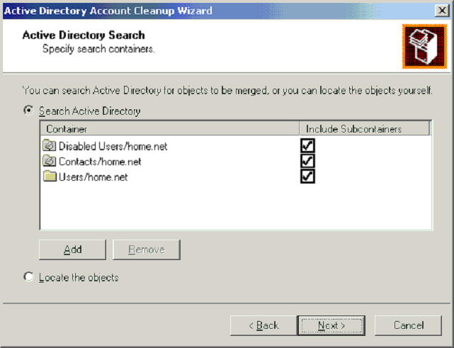

Figure 20 AD Clean Up Scope Selection
Similarly, only merge operations on user accounts where only one is mailbox-enabled is supported. You cannot merge two user objects together where both objects have mailboxes associated with them. The merging of active user accounts between domains is also not supported, but if only one is active then this functionality is available.
When merging Active Directory objects you must always merge into an active user object, not a disabled object. Similarly, since it’s also possible to merge with Active Directory Contacts, you can’t merge into a Contact, but you can merge a Contact into an enabled user object.
AD Clean Up allows you to review the candidate merge operations it has decided on, rather than just going off and merging objects together. This would not be desirable behavior. Furthermore, if after running an AD Clean Up prepare operation, you find that there are objects that AD Clean Up has not selected for merging, you can manually specify other merge operations to take place, provided of course that they adhere to the supported models. When AD Clean Up runs, it preserves Windows 2000 permissions and Distribution Group membership during merge operations.

AD Clean Up Operation
AD Clean Up operates more successfully when it is merging security principals together, rather then merging just a security principal and a Contact object. This means that when using the ADC to create objects in the Active Directory, life will be easier for AD Clean Up if you don’t configure it to create Contacts. (Similarly, when using the account migration tools as described in the next section, in-flight object merging works best with user objects, not Contacts, so it’s best practice not to create Contacts at all.)
You can see an example of some merge candidates in Figure 21.

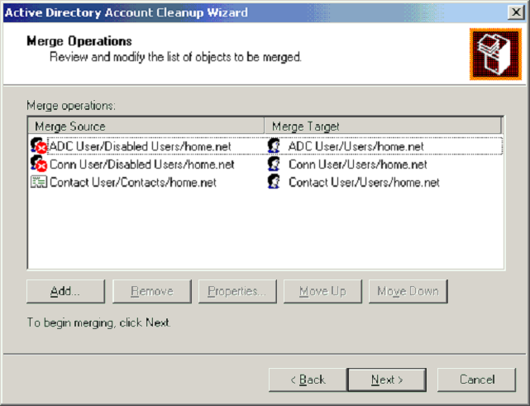

Figure 21 AD Clean Up Merge Candidates

Merging User Objects
During a merge operation AD Clean Up searches for twin objects, it matches the SID or sIDHistory attributes from the live user object with the msExchMasterAccountSID attribute from the disabled user account. This attribute is populated by the ADC.
Disabled mailbox-enabled users can be merged with live user objects automatically, or live mailbox-enabled users can be merged with live user objects manually.

Merging Contact Objects
Merge operations with Contact objects are generally of a lower quality than merge operations where both objects are security principals. Because Contacts are not security principals, they do not have any associated SID information, specifically, there is no msExchMasterAccountSID attribute with which to provide high fidelity matching.
For this reason, Contact matches are performed on either CN or displayName attributes. Matching on names is generally not as exact as matching on numbers, so there is a higher risk that duplicate objects may not be detected. Matching can also take place on the Mail-Nickname (Alias) and samAccountName attributes. Again, these are name-based and typically less exact.

Windows NT and Exchange Migration Scenarios

Migration Fundamentals
There are a number of guiding principles that we should adhere to with regard to moving from Windows NT4 and Exchange 5.5 to Windows 2000 and Exchange 2000. Any migration activity should be low risk and easy to recover from should something go wrong. We should impact the users as little as possible (for example, service interruption or rebuilding desktop systems). Finally, the effort required to complete the migration to Windows 2000 and Exchange 2000 should be kept to a minimum.
We need to decide on an approach that can be taken to get us to the end zone. Two main approaches exist (although there are variants of each) when migrating. Either we upgrade existing Exchange 5.5 servers, or we establish an integrated coexisting environment by placing new Exchange 2000 servers in the Exchange 5.5 environment and moving users over to the new infrastructure. Irrespective of which approach you take, you still need to provide good interoperability between the Exchange 5.5 and Exchange 2000 infrastructures for the duration of the migration. Within a single Exchange organization, this coexistence is shown diagrammatically in Figure 22.
5.5 Site
Mixed Site
2000 AG
5.5 Site
5.5 Site
Austin Org
Link between Exchange 5.5 and Exchange 2000 Servers

Figure 22 Exchange 5.5 and Exchange 2000 Coexistence Environment
In the diagram, we’ve integrated a new Exchange 2000 infrastructure into an existing Exchange 5.5 environment. This is done by creating an Exchange 2000 server (either as an upgrade from Exchange 5.5 or as a new Exchange 2000 installation) in an existing Exchange 5.5 site. With this link in place, and the associated ADC connections and mail connections to support it, we can provide more or less seamless interoperability between Exchange 5.5 and Exchange 2000. If integration isn’t achieved at this level, then you essentially end up with a separate Exchange 2000 organization (different from the Exchange 5.5 organization). In this case, you’re faced with the age-old problem of inter-organization interoperability, for example: directory synchronization (made easier using the ADC), mail connectivity, and perhaps most importantly, public folder interoperability.
There are pros and cons associated with upgrades or Exchange organizational restructuring using fresh installs. Upgrading existing servers makes use of existing hardware but impacts service levels since systems are unavailable for the duration of the upgrade. Adding new Exchange 2000 servers to the existing Exchange 5.5 sites results in new hardware being required, but user impact is reduced as users can be moved from one server to another in a short period of time. Whichever approach you take, the best way to get there is to ensure that you’ve completed a move to Windows 2000 for account domains. If you haven’t fully completed this exercise, then although you can still migrate to Exchange 2000, it becomes much more complex.

Migration Terminology Refresher
There are a number of key terms that we’ll meet over and over again when we talk about migrating from Exchange 5.5 to Exchange 2000. Some of the terms have been introduced and explained in passing, but they are critically important to understanding the nature of migration, and the behavior that you see as users are moved. For clarity, these terms are fully described in the following sections.

Distinguished Names (DNs)
We’ll discuss DNs at length. There are essentially two types: Exchange 5.5 Directory Service DNs; and Active Directory DNs. Objects in the Exchange 5.5 Directory Service are uniquely identified by their DN, while objects in the Active Directory are uniquely identified by their Global Unique ID (GUID).
An Exchange 5.5 Directory Service example might be:
/o=Austin/ou=sales/cn=recipients/cn=MikeM
An Active Directory example might be:
cn=MikeM, cn=Users, dc=Austin, dc=com

legacyExchangeDN
Under certain circumstances, for example, when synchronizing legacy Exchange 5.5 Directory Service objects with Active Directory objects, it’s important that an object that has been migrated from the Exchange Directory Service to remember how it was uniquely identified in the Exchange Directory Service. The legacyExchangeDN attribute holds this information and acts as a link back to the Exchange object.

Security Identifier (SID)
SIDs uniquely identify objects in the NT4 SAM account database so clearly, there are two unique representations of objects in Windows NT4 and Exchange 5.5. The SID is important because it’s used as the primary mechanism to enforce security controls in NT4.

sIDHistory
As with the legacyExchangeDN attribute, it’s often important that an object migrated from the Windows NT4 SAM database to an Active Directory object remembers its SID from its Windows NT4 lifetime. The sIDHistory attribute performs this function and the ClonePrincipal API utility used by the Windows 2000 migration scripts and tools populates this Active Directory attribute when a new security principal is created in Windows 2000. Note that upgrading a Windows NT4 domain to Windows 2000 does not populate the sIDHistory attribute.

msExchMailboxSecurityDescriptor and msExchMasterAccountSID
When creating security principals in the Active Directory, the ADC does not populate the sIDHistory attribute, but it will inspect it when trying to match objects. Instead, the ADC stores legacy SID information (which links the Exchange 5.5 mailbox object to a Windows NT4 account) in the msExchMailboxSecurityDescriptor and importantly for the AD Clean Up Wizard, msExchMasterAccountSID attributes.
In fact, the sIDHistory attribute is only available when the Windows 2000 domain is in native mode. A special auditing policy is enabled on the Windows 2000 Domain Controller and the NT4 PDC, and a registry key is set to access the Windows NT SAM database. There’s no guarantee that the target domain will be in native mode when running an ADC, so therefore write access to the attribute is unavailable.

Clearing The Way: Running Exchange 5.5 on Windows 2000
As part of the journey to Exchange 2000, many organizations will first update all of their Windows NT4 infrastructure (not just Master Account Domains) to Windows 2000. If you intend to do in-place upgrades of Exchange 5.5 to Exchange 2000, it will be an absolute requirement that at some stage you have Exchange 5.5 running on a Windows 2000 server.
Of course there’s no absolute requirement that you must have Exchange 5.5 running on Windows 2000. If you don’t want to upgrade servers in-place (more about this restructuring option later) then you don’t need to upgrade an Exchange 5.5 server from Windows NT4. Since you’ll be moving users to a Windows 2000/Exchange 2000 server, what’s the point of upgrading systems from Windows NT4 to Windows 2000? Remember one of the guiding principles: minimal effort.

Flattening Windows NT4 Domains
If you do want to upgrade in-place, be sure to get Exchange 5.5 SP3 deployed before you start the process. This approach provides an opportunity to flatten Windows NT4 domains into a more manageable model and potentially eliminate a wealth of resource domains that you may have had. If you had Exchange 5.5 servers running on Windows NT4 BDCs, you now have an opportunity to fold them back into Windows 2000 Master Account Domains as Member Servers. It’s important that you do this, since it simplifies topology and administration.
In the Exchange 5.5 and Windows NT4 days it was best practice to either have Exchange 5.5 running on a BDC for a resource domain, or at least have a BDC logically close by. In moving to Windows 2000, it’s desirable to get the domain into native mode as quickly as possible. It’s easy to do this with Windows NT4 Member Servers since they can exist in a Windows 2000 native mode domain. However, Windows NT4 PDCs and BDCs can’t exist in a Windows 2000 native mode domain, so it’s imperative to have these servers upgraded to Windows 2000 quickly. While there’s no great technical challenge associated with this move, it is yet another hurdle that you have to jump over before you can begin your Exchange 2000 migration in earnest.

Ways To Get There
Clearly there are two ways to move from a multi-domain Windows NT4 infrastructure to a streamlined Windows 2000 infrastructure. You can either perform in-place domain upgrades and then restructure your Windows 2000 domains later, or you can build new Windows 2000 servers and move Exchange 5.5 databases to them. This second approach is very appealing since it allows you to get a fresh operating system platform in place and is ideal for automated platform deployments.

The Classic Upgrade Scenario

Upgrade Assumptions
The most important assumption associated with the classic upgrade is what needs to be done to the Windows NT4 accounts. You can’t have an Exchange 2000 mailbox unless you have a Windows 2000 account. So, you must have completed your migration from Windows NT4 account domains to Windows 2000 account domains before you start upgrading Exchange 5.5 servers.
You must also have taken steps to get Exchange 5.5 running on Windows 2000 so the upgrade can proceed, specifically running SP3.

Upgrade Process
Before starting the upgrade process, you must have an ADC in place. This is required at the very least for the automatic configuration of the CCAs, but it is also used during the upgrade process, which converts Exchange 5.5 Directory Service objects to their Active Directory equivalents.
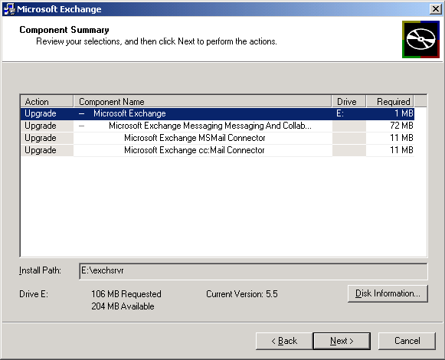

Figure 23 Setup Program Upgrade Options
Upon running the SETUP program, you are confronted with the option to upgrade the existing installation to Exchange 2000 (as shown in Figure 23). It should be noted that Exchange 2000 uses a different database structure than Exchange 5.5, so in addition to the time required just to upgrade the binaries, the total upgrade time is dependent on the size of the Information Store databases.

Upgrade Internals
Let’s look at the simple case of what happens when a single Windows NT4 and Exchange 5.5 server is upgraded to Windows 2000 and Exchange 2000. We start off with a Windows NT4 SAM entry for the user and an Exchange 5.5 Directory Service Entry, as shown in Figure 24.
NT4 SAM
username:POWERS\kensington
sid:12345
5.5 Mailbox
Display-Name:Kensington, Vanessa
Obj-Dist-Name:/o=powers/ou=LON/cn=recipients/cn=KensingtonV
Assoc-Nt-Account:<encoded>“POWERS\kensington”
NT-Security-Descriptor:12345
Alias:KensingtonV

Figure 24 Legacy Account Information Before Upgrades
After the upgrade from Windows NT4 to Windows 2000, users can still access their Exchange 5.5 mailboxes because the access information has been preserved through the in-place Windows NT4 upgrade. That is, the Assoc-NT-Account that points to the NT4 SID is consistent because the same SID is available after the upgrade (this occurs because the down-level domain name and username are static).
Immediately following the Windows NT4 upgrade, we are left with a new Windows 2000 account, the details of which are shown in Figure 25. Notice that the DN is kensington.
Win2k Accounts
DN:cn=kensington, cn=users, dc=Powers
sID:12345

Figure 25 Windows 2000 Account Details after Upgrade
Following the account domain upgrade, the ADC should be installed and the appropriate CAs put in place and executed to map the Exchange 5.5 mailbox to the new Windows 2000 account. After running the CA, the Windows 2000 account will be updated to reflect the Exchange 5.5 mailbox, specifically you should notice that the DN changes after ADC synchronization. This is evidence that the Exchange 5.5 mailbox details have been merged with the Active Directory object and the new values that you should expect to see are shown in Figure 26.
The important concern here is access to the Exchange 5.5 mailbox. There is no interruption to mailbox access since the down-level account name has remained the same.
Win2k Accounts:
DN:cn=Vanessa Kensington,cn=users, dc=Powers
sID:12345
legacyExchangeDN:/o=powers/ou=LON/cn=recipients/cn=VanessaK
msExchHomeServerName:/o=powers/ou=LON/cn=Configuration/cn=Servers/cn=foobar
Figure 26 Updated Windows 2000 Account Following ADC Synchronization
Following the ADC run, you can then run the Exchange 2000 setup program, which upgrades the server and mailboxes.

Upgrade Benefits and Drawbacks
Performing in-place upgrades means that you reuse your existing hardware, so it’s attractive from this perspective. Also, if your environment is reasonably straightforward and requires little modification, this is the natural approach to take since it doesn’t require anything in the way of restructuring or the use of external migration tools. In addition, the account passwords remain the same.
On the other hand, the existing hardware on which you running Windows NT4 and Exchange 5.5, may not be suitable for Windows 2000 or Exchange 2000. If that’s the case, and you need to upgrade hardware, then you’ll be hit for extra cost in any event.
In this case, the biggest drawback is service interruption. Servers must be taken offline to perform both Windows 2000 and Exchange 2000 upgrades. Even if you do this out of hours, it’s a major disruption and can take many hours. Also, because we’re operating on server-granularity level, it can take considerable time to recover if something goes wrong, for example, restoring backup tapes and getting users up and running again.

Upgrading Clusters
Upgrading a cluster is not simple task! Unfortunately, there’s no out-of-the-box mechanism by which a cluster can be upgraded. What this means is that there is no way to simply run the SETUP program from the Exchange 2000 installation CD on a cluster and upgrade it from Exchange 5.5 to Exchange 2000.
Instead, we must use one of two approaches: a cluster server rebuild process à la disaster recovery; or we must introduce a new Exchange 2000 cluster into the same site and move users on to it. Let’s look at the disaster recovery option first.
With the disaster recovery mode of upgrade, we essentially save the existing Exchange 5.5 databases, torch the existing hardware, that is, reinstall the operating system and Exchange 2000 from scratch, and build a new, Exchange 2000 cluster. When we’ve got the new cluster built using existing hardware, we can restore the old cluster databases onto the new cluster, and after the databases have been upgraded, we end up with a new Exchange 2000 cluster. This approach is somewhat convoluted but it will be well documented and should be relatively straightforward. As with an in-place upgrade, it suffers from the fact that it will be taken out of service for a period of time; probably a good few days while it’s backed, rebuilt, and then restored, which represents a considerable impact to user service levels.
The alternative upgrade approach is along the lines of the general restructuring approach, which we can use for any type of Exchange 5.5 server. We’ll discuss the approach in more detail later, but essentially it allows us to install a brand new cluster into the same site as the Exchange 5.5 cluster and simply move users from the old cluster to the new one. This approach has many attractions, not least because of the fact that we get an opportunity to use new hardware, which is particularly important for Exchange 2000 clustering, but also because there is significantly less impact on server availability to the users.

The Restructuring Scenario

Restructuring Assumptions
One of the biggest assumptions we make with this approach, and in fact, the most important factor related to its relative ease as an upgrade mechanism, is that the migration of account domains from Windows NT4 to Windows 2000 is complete. If the migration isn’t complete, then the restructuring scenario becomes quite messy from an Active Directory perspective and essentially turns into the Hybrid Scenario that we’ll describe in the next section.
Of course, with a restructuring approach, much like the approach that you might take for Windows 2000 restructuring, you need to invest in some new hardware on which to run the parallel Exchange 2000 environment. This does not mean that you need to replace every single Exchange 5.5 server system with new hardware for Exchange 2000. You may do this, or you may take the opportunity to consolidate server systems and replace several Exchange 5.5 systems with a single Exchange 2000 server, perhaps even a cluster. This Pacman approach is appealing because it builds on the strengths of Exchange 2000. Alternatively, you may be able to reuse old Exchange 5.5 hardware with a Moving Train approach. That is, kick start the restructuring operation by introducing a new Exchange 2000 server on new hardware and move Exchange 5.5 users onto this server, thus freeing up the old hardware that Exchange 5.5 was running on for recycling.

Restructuring Process
In terms of Exchange 2000 restructuring, what you do not want to do is build a new Exchange 2000 organization that is separate from the existing Exchange 5.5 organization. This does not offer a coexistent environment or rich interoperability. What we do want to build is a new Exchange 2000 environment that is integrated into the existing Exchange 5.5 environment. The simplest way to do this is to select an existing Exchange 5.5 site to join during the ForestPrep phase of the Exchange 2000 installation, as shown in Figure 27. When you select this option, the next setup screen prompts you to specify the name of an Exchange 5.5 server in the site that you want to join. Consequently, RPC communications take place and configuration information is read from the Exchange 5.5 Directory and written into the Active Directory Configuration naming context.
What happens in this case is that we install the Exchange 2000 server into a legacy Exchange site: a site that must have at least one Exchange 5.5 server. Such a site is often referred to as a mixed vintage site. The site can have previous versions of Exchange in it too; that is, Exchange 4.0 and Exchange 5.0.
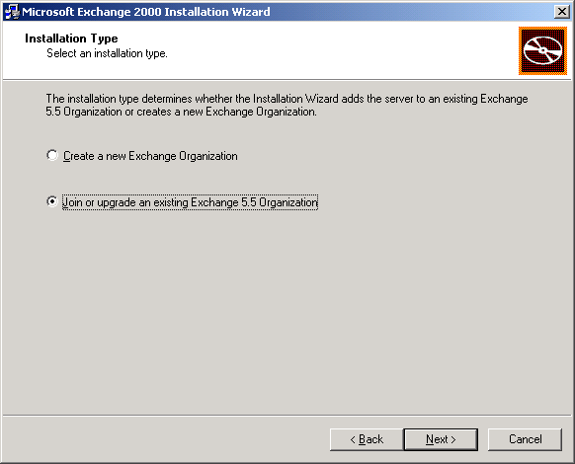

Figure 27 Running Exchange 2000 Setup to Join an Existing Exchange 5.5 Organization
Before an Exchange 2000 server can be installed in an Exchange 5.5 site, you must already have an ADC in place. Obviously, you’ll need the ADC there to support CAs for the recipient containers and OUs that you want to synchronize, but just as importantly, the installation process creates a CCA so that configuration information can be synchronized between the Exchange 5.5 and Exchange 2000 environments. During installation, Setup chooses the first ADC returned to it by a Domain Controller in order to home the CCA. If you have multiple ADCs then, say one in each major geographical area, it’s possible that you may find an Americas ADC being used to host a CCA for a site in Europe. There’s no way to control this during installation, but you should review the placement of CCAs after installation and re-locate remote CCAs to local ADCs if they’ve been located incorrectly, thus improving configuration information synchronization performance.
The beauty of the mixed vintage site is that you wind up with Exchange 2000 servers in Exchange 5.5 sites, operating seamlessly and transparently to your users. Within the site, the Exchange 2000 server looks pretty much just like any other Exchange 5.5 server when viewed from the Exchange 5.5 Administrator program, and similarly, Exchange 5.5 servers can be viewed from the Windows 2000 Exchange System Manager MMC snap-in and appear, pretty much, like any other Exchange 2000 server. (Examples of these views are shown in Figure 28 and Figure 29.)
Since the servers are visible from both management interfaces, it’s not surprising to learn that the servers can be managed from either management utility, but Compaq’s best practice recommendation is to manage like with like and avoid crossing the streams for management.
Within a mixed vintage site, legacy Exchange servers and Exchange 2000 servers communicate using RPCs for MTA-to-MTA communication, SRS-based intra-site replication, and Exchange 5.5 Administrator communications.

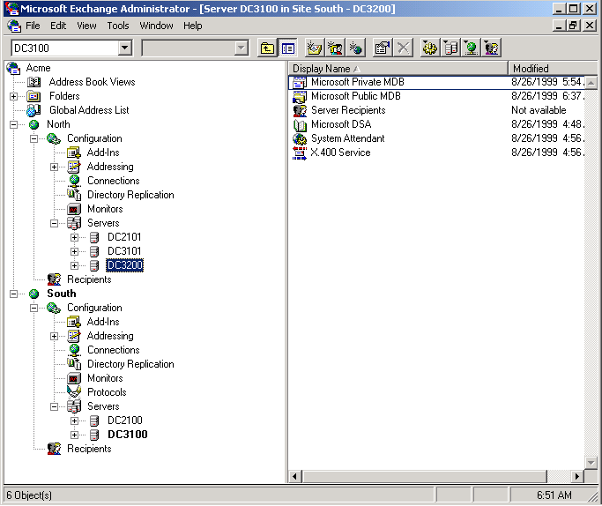

Figure 28 Exchange 5.5 Administrator Program Showing Exchange 2000 Servers (DC3200 is the only Exchange 5.5 Server)

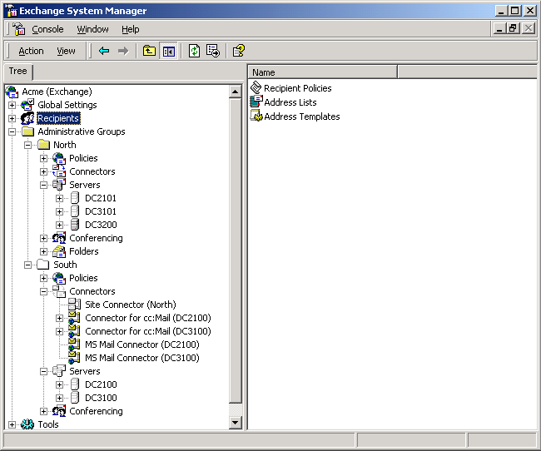

Figure 29 Windows 2000 Exchange System Manager MMC Snap-in Showing an Exchange 5.5 Server (DC3200)
In an Exchange 2000 mixed mode organization, Exchange 5.5 sites map directly to Exchange 2000 Administrative Groups (individual servers can’t be moved between Administrative Groups and Routing Groups until the Exchange 2000 organization is running in native mode). Sites are represented as a fixed Administrative Group/Routing Group pair. You can see this mapping of sites and Administrative Groups by comparing the North and South sites shown in Figure 28 with the North and South Administrative Groups shown in Figure 29.
Although legacy Exchange server to Exchange 2000 server communication within a mixed vintage site takes place using RPCs, if there are multiple Exchange 2000 servers in the site, they communicate with each other using native SMTP, as they would do in a normal Exchange 2000 Routing Group. Additionally, one of the Exchange 2000 servers in a mixed vintage site acts as the Routing Group Routing Master and generates the Link State Table to provide optimized routing information to the other Exchange 2000 servers in the site (Administrative Group/Routing Group pair). In addition, the Routing Master will actually generate the Gateway Address Routing Table (GWART) on behalf of the Exchange 5.5 servers in the site. Normally the Exchange 5.5 Routing Information Dæmon Master (RID Master) generates the GWART, but since the Exchange 2000 servers have the best knowledge of the whole mixed Exchange routing environment (they see configuration information from Exchange 5.5 directory replication, Active Directory configuration information, and from the exchange of Link State information from other Exchange 2000 servers) they generate a more complete GWART.
Having built our closely integrated mixed vintage site, there’s now a really straightforward way to move users from Exchange 5.5 to Exchange 2000. It’s called point-and-click! You can use the Windows 2000 Active Directory Users and Computers MMC snap-in to select the Exchange 5.5 mailbox (a Windows 2000 user at this stage, of course). Simply right-click, and select Exchange Tasks and then Move Mailbox Wizard and indicate to which Exchange 2000 server the mailbox should be moved. (Figure 30 shows a screen display from part of this process.)
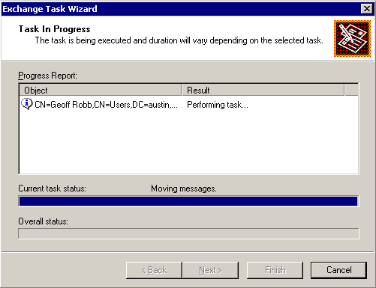

Figure 30 Exchange Move Mailbox Wizard Progress Screen
Single instance storage is preserved across moves, but this may not be too important to you since many customers, especially large organizations, have observed poor single instance ratios. Having said that, it does make sense to move groups of users together, say those that work in the same department or on the same project, to the same server, thus encouraging single instance behavior.

Restructuring Internals
Let’s take a look at the process of restructuring and what happens when Windows NT4 accounts are migrated to Windows 20000 in advance of mailbox migration.
We start with a Windows NT4 account and Exchange 5.5 mailbox, as shown in Figure 31.
NT4 SAM
username:POWERS\kensington
sid:12345
5.5 Mailbox
Display-Name:Kensington, Vanessa
Obj-Dist-Name:/o=powers/ou=LON/cn=recipients/cn=Kensington
Assoc-Nt-Account:<encoded>“POWERS\kensington”
NT-Security-Descriptor:12345
Alias:Kensington

Figure 31 Windows NT4 and Exchange 5.5 Account Information
Account migration takes place before any Exchange mailboxes are moved, so new Windows 2000 accounts are created in the newly restructured domain. This process can either disable the existing Windows NT4 accounts or they can remain enabled and in use. However, it makes sense to disable the old accounts and use the new Windows 2000 accounts. As we’re creating new accounts, the new Windows 2000 objects get a new SID, and if the appropriate migration tools, such as Bindview, Fastlane, and Mission Critical have been used, the sIDHistory attribute will be set on the new object to reflect its relationship to the old Windows NT4 account, as shown in Figure 32.

Win2k Accounts
DN:cn=kensington, cn=users, dc=Austin, dc=com
sAMAccountName:kensington
sID:56789
sIDHistory:12345

Figure 32 Restructured Windows 2000 Account
Access to the Exchange 5.5 mailboxes will be preserved since the down-level account names and the sIDHistory attribute is maintained in the new account.
When the first ADC run takes place, the Exchange 5.5 mailbox is matched against the Windows 2000 account based on the sIDHistory attribute and the Windows 2000 account information is merged with information from the Exchange 5.5 mailbox directory entry, resulting in an updated Windows 2000 object as shown in Figure 33.
Win2k Accounts:
DN:cn=Vanessa Kensington,cn=users, dc=Austin, dc=com
sAMAccountName:kensington
sID:56789
sIDHistory:12345
legacyExchangeDN:/o=powers/ou=LON/cn=recipients/cn=Vanessa
msExchHomeServerName:/o=powers/ou=LON/cn=Configuration/cn=Servers/cn=foobar
Figure 33 ADC Updated Windows 2000 User Account
You can control how the ADC matches Exchange 5.5 objects against Active Directory objects by setting a global ADC policy, as shown in Figure 34. In the diagram, you can see that this matching rule will link the Exchange 5.5 Directory Service Assoc-NT-Account, (which would have been the old Windows NT4 SID) against the Active Directory object sIDHistory attribute.
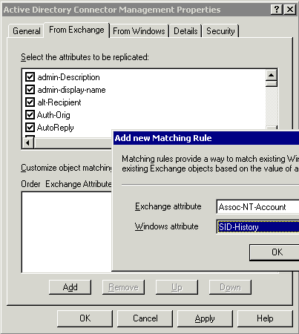
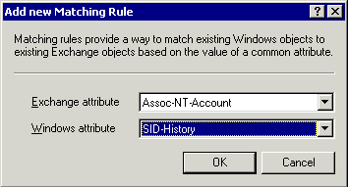

Figure 34 ADC Matching Rules
Following the ADC run, you can then proceed to install Exchange 2000 servers into Exchange 5.5 sites and simply move users’ mailboxes from the legacy servers to the Exchange 2000 servers.

Restructuring Benefits and Drawbacks
The restructuring scenario described above represents the lowest impact migration activity to Exchange 2000. Instead of the extended time required to upgrade a server to Windows 2000, and then subsequently upgrade to Exchange 2000 during which user mailboxes are unavailable, you can simply build the new server alongside the live service and move users either one at a time or using scripts written with Exchange Management Objects. From a user perspective, there is little interruption to service.
And as well as making migration from Exchange 5.5 servers straightforward, it’s also quite possible to simply move users from Exchange 4.0 and Exchange 5.0 systems, without the need to upgrade to Exchange 5.5. The migration granularity, this time on a mailbox, as opposed to a server with the upgrade activity, also presents significantly less risk. This is also a simple way to consolidate hardware systems and reuse hardware by virtue of the Pacman and Moving Train approaches that were mentioned earlier.
While this approach is desirable for many reasons, it can be more expensive since a parallel infrastructure of some description must be in place. However, it’s likely that your hardware will need to be improved for Windows 2000 and Exchange 2000, so this point may be moot. Similarly, the Moving Train approach allows existing hardware to be reused, so the costs may not be prohibitive. Think of your users’ quality of service before all else!

The Hybrid Scenario

Hybrid Assumptions
The assumptions associated with the Hybrid Scenario basically negate the best practices associated with both the Classic Upgrade and the Restructuring scenarios. In both of those approaches, we made sure that all account domain migration from Windows NT4 to Windows 2000 had been completed. If this is done, any form of migration is relatively pain-free.
The basic premise of the Hybrid approach is that this account domain upgrade is either not completed before you start to move to Exchange 2000, or it is started at the same time and runs in parallel to an Exchange 2000 migration. Effectively, what’s important is the sequencing of when ADC synchronization runs, in relation to account domain migration. Put the ADC in place before you’ve completed your account domain migration and life becomes more difficult.

Hybrid Process
With the Hybrid migration, during the mid point of the migration we find ourselves with a mix of Windows NT4 and Windows 2000 users, along with a mix of Exchange 5.5 and Exchange 2000 users. Although hybrid migrations are the most complex, it’s equally likely that they’ll be the most common for sizeable organization.
The major complication with the hybrid scenario is the risk of Active Directory object duplication. In the other scenarios, the ADC was always able to match an Exchange 5.5 mailbox to a Windows 2000 account, but with the hybrid approach, an Exchange 5.5 user that has not migrated will have two account identities. There’ll be a Windows NT4 account associated with the Exchange 5.5 mailbox and there will also be a Windows 2000 user object (or potentially a Contact) in the Active Directory. The problem arises when the Windows NT4 account is migrated to Windows 2000. In this circumstance, we rely on intelligence in the account migration tools to recognize that an object already exists in the Active Directory referencing this user.
Simply creating a new account in Windows 2000 may not be appropriate since this process will not carry across any Windows NT4 account history (so permission structures will be lost). Similarly, just using an object already created by the ADC may not be appropriate since there is no sIDHistory associated with an ADC-created object, so again, permission structures are lost.
Some of the leading Windows 2000 migration tools seem to be able to deal with the situation relatively well. For example, Microsoft’s ADMT, Bindview’s (formerly Entevo) Direct Migrate 2000, Fastlane’s DM Suite Manager, and Mission Critical Software’s One Point Domain Migration Administrator all help (with varying degrees of sophistication) to merge legacy Windows NT4 accounts with new Windows 2000 account objects (probably created by the ADC). Of course, the ADC allows you to create mail-enabled Contacts (as well as enabled or disabled user objects) in the Active Directory to represent Exchange 5.5 users. However, as these Contacts aren’t security principals, it’s more difficult to merge with them at Windows NT migration time.
If you use migration tools that aren’t intelligent enough to detect an existing account and merge with it, or you just create new users, then you may well end up with a live user account as a result of the account domain migration and a user account or contact as a result of previous ADC synchronization. In this case you’ll need some way to rationalize the duplicate objects and merge them together. AD Clean is used for this purpose.

Hybrid Internals
Let’s take a look at a typical sequence of events that you might expect to see with a hybrid migration. Obviously, we don’t assume that there is an object in the Active Directory that references the Exchange 5.5 mailbox, so we do assume that the ADC will create a security principal (either an enabled or disabled user object, not a contact) when synchronization takes place. So, we begin with a Windows NT4 account and an Exchange 5.5 mailbox like that shown in Figure 34.

NT4 SAM
username:AUSTIN\exposition
sid:12345
5.5 Mailbox
Display-Name:Exposition, Basil
Obj-Dist-Name:/o=austin/ou=SEA/cn=recipients/cn=ExpositionB
Assoc-Nt-Account:<hex encoded> “exposition”
NT-Security-Descriptor:12345
Alias:ExpositionB

Figure 34 Windows NT4 and Exchange 5.5 Mailbox pre-Hybrid Migration
As a matter of best practice, we’ll have the ADC create a disabled user account for an Exchange 5.5 mailbox if it can’t match it against an existing Windows 2000 account. The disabled user object gets a new SID in Windows 2000 and of course has a new DN. The Active Directory DN is actually built from the Exchange 5.5 mailbox alias name (this is important later), and is represented in the Exchange 5.5 Directory Service as Mail-Nickname. The primary Windows NT4 account SID is saved in the msExchMailboxSecurityDescriptor and msExchmasterAccountSID attributes. (Remember that sIDHistory is not populated by the ADC.) In addition, the legacy Exchange 5.5 DN is stored in the legacyExchangeDN attribute. This results in an ADC-synched Active Directory object like that shown in Figure 35.
Synched 5.5 Mailboxes
Disabled User:
DN:cn=ExpositionB, cn=users, dc=powers, dc=com
sID:6789
msExchMailboxSecurityDescriptor:12345
msExchMasterAccountSID:12345
legacyExchangeDN:/o=austin/ou=SEA/cn=recipients/cn=ExpositionB
homeMDB:<5.5 Mailbox>

Figure 35 ADC-synched Active Directory Disabled User object
Typically, the next step will be to migrate the Windows NT4 account to Windows 2000. Using the proper migration tools, you’ll avoid object duplication we’ll look at these scenarios later), but in the worst, and quite likely case, you may wind up creating another security principal in the Active Directory. For example, using the ClonePrincipal API script, will result in a new object being created for this user with a new DN, a new SID, and the old SID being placed in the sIDHistory attribute. This results in two objects in the Active Directory now referencing the same person, as shown in Figure 36.
Synched 5.5 Mailboxes
Disabled User:
DN:cn=ExpositionB, cn=users, dc=powers, dc=com
sID:6789
msExchMailboxSecurityDescriptor:12345
msExchMasterAccountSID:12345
legacyExchangeDN:/o=austin/ou=SEA/cn=recipients/cn=ExpositionB
homeMDB:<5.5 Mailbox>
Win2k Accounts
Enabled User:
DN:cn=exposition, cn=users, dc=powers, dc=com
sID:13579
sIDHistory:12345

Figure 36 Two objects in the Active Directory for the Same Person
Notice the different SID values for these objects and also pay particular attention to the DNs for each one. The DN for the ADC-created object has an RDN of ExpositionB, while the migrated Windows NT4 account has an RDN of exposition, built from the Windows NT4 account name.
Before we can proceed, it makes sense at this stage to run AD Clean to merge both the security principals for Basil Exposition together into a single object. This results in an enabled user account similar to that shown in Figure 37. When AD Clean operates, the source (disabled) object attribute information is always merged into the target (live) object attribute information, resulting in a single enabled security principal.
Win2k Accounts:
DN: cn=exposition,cn=users, dc=powers, dc=com
sID:13579
sIDHistory:12345
msExchangeMailboxSecurityDescriptor:12345
msExchMasterAccountSID:12345
legacyExchangeDN:/o=austin/ou=SEA/cn=recipients/cn=ExpositionB
homeMDB:<5.5 Mailbox>

Figure 37 Merged Active Directory Object
Following this, the ADC will run and will match the Exchange 5.5 mailbox with the new Windows 2000 account (matching on sIDHistory). This results in the Active Directory object being modified such that the DN becomes more user friendly, as shown in Figure 38.

Win2k Accounts:
DN: cn=Basil Exposition,cn=users, dc=powers, dc=com
sID:13579
sIDHistory:12345
msExchangeMailboxSecurityDescriptor:12345
msExchMasterAccountSID:12345
legacyExchangeDN:/o=austin/ou=SEA/cn=recipients/cn=ExpositionB
homeMDB:<5.5 Mailbox>

Figure 38 ADC-updated Merged Active Directory Object
The final step in this process is to move the Exchange 5.5 mailbox information to the Exchange 2000 server using the Active Directory Users and Computers snap-in. The migration is complete.

Using Migration Tools
The example migration process shown above is pretty much a worse case scenario in that duplicate accounts are created because there is no intelligence applied at the point when the Windows NT4 account is migrated to Windows 2000.
At the time of writing, the third party migration tools apply some intelligence to this point but not as much as one would like. For example, Bindview’s Direct Migrate 2000 tool will perform matching based on the sAMAccountName attribute which is set to the same value as the Alias name. So, if you have an Exchange 5.5 mailbox with an Alias value that is the same as the Windows NT4 username, then Direct Migrate 2000 will merge the migrated Windows NT4 account with the ADC-created disabled user object.
However, if the Alias name is different from the Windows NT4 username, then no matching takes place and duplicate objects are created. It’s likely that the migration tools will perform matching on other attributes in future, for example, msExchMasterAccountSID or msExchMailboxSecurityDescriptor. This should improve migration fidelity considerably and reduce the need to run AD Clean.

Hybrid Benefits and Drawbacks
The only benefit associated with the Hybrid migration scenario is that it facilitates a timely and rapid move to Exchange 2000 because there is no need to wait on the completion of an account domain migration to Windows 2000.
This is its greatest strength and weakness. The synchronization model is very complex and will almost certainly result in duplicate object creation in the Active Directory. This means that you will have to run AD Clean. To avoid the clean up headache, the only alternative is to use sophisticated third party migration tools, and although there may be some cost associated with this, it’s likely that they will save much pain in the long run.
Dealing With Distribution Lists

Native Membership
Membership information for Distribution Lists and Distribution Groups is always maintained in its native object format. Exchange 5.5 Distribution Lists show native Exchange DNs as members and Windows 2000 Groups show native Windows 2000 DNs as members. This is shown in Figure 39.

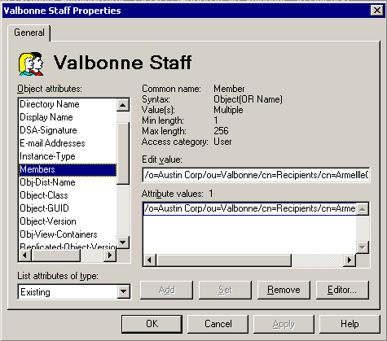
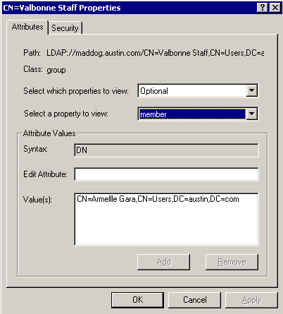

Figure 39 Distribution Lists and Distribution Groups Native Membership
Not only does this mean that we have to think about how DLs themselves are maintained as they are replicated (for example, membership latency) we also need to think about what happens when Exchange 5.5 mailboxes are migrated to Exchange 2000 mailboxes. In particular, how is the integrity of the distribution list maintained?
5.5 Mailbox
Display-Name:Powers, Austin
Obj-Dist-Name:/o=Star/ou=SEA/cn=recipients/cn=PowersA
Synched 5.5 Mailboxes
Disabled User:
DN:cn=PowersA,cn=Users,dc=Austin,dc=com
legacyExchangeDN:/o=Star/ou=SEA/cn=recipients/cn=PowersA
memberOf:cn=Agents,cn=Users,dc=Austin,dc=com
homeMDB:<5.5 Mailbox>
5.5 Distribution List
Display-Name:Agents
Obj-Dist-Name:/o=Star/ou=SEA/cn=recipients/cn=Agents
Members:/o=Star/ou=SEA/cn=recipients/cn=PowersA
Synched 5.5 Groups
Distribution Groups:
DN:cn=Agents,cn=Users,dc=Austin,dc=com
legacyExchangeDN:/o=Star/ou=SEA/cn=recipients/cn=Agents
member:cn=PowersA,cn=Users,dc=Austin,dc=com

Figure 40 Relationship between Native Directory Objects and Distribution Lists

Figure 40 shows the internal relationships between the native Exchange 5.5 Directory Service objects, and their ADC-synched Active Directory counterparts. We only start to look at the migration process some time after the Windows NT4 account for the user has been migrated to Windows 2000; since the mailbox couldn’t be moved to Exchange 2000 if this wasn’t the case, and therefore we wouldn’t have a problem!
At this point, the ADC will be mapping the Exchange 5.5 mailbox to a Windows 2000 account and accordingly, you can expect to see the legacyExchangeDN attribute reference the Exchange 5.5 object’s DN in the Exchange 5.5 Directory Service. As the user mailbox is moved, the Exchange 5.5 mailbox object remains in place in the Exchange 5.5 Directory Service. When the ADC synchronization instance that maps the Exchange 2000 mailbox-enabled users back to the Exchange 5.5 Recipient container runs, the attributes are merged, but the Exchange 5.5 mailbox Directory Service object now refers to the newly migrated Exchange 2000 mailbox. In this way, since the DN of the Exchange 5.5 Directory Service object never changes, there is never any risk of compromising the integrity of the Distribution List membership.
There is an important point to draw from this example. Irrespective of the CAs that you use to map Active Directory objects to the Exchange 5.5 Directory Service containers, you must always have a CA that maps Exchange 2000 mailbox-enabled users back to the Exchange 5.5 Recipients container.

Desktop Impact from Migration Activity

Maintaining MAPI Profile Information
Maintaining the MAPI profile during a migration exercise is critical to a successful project. If desktops are upgraded, care should be taken to ensure that the MAPI profile information, maintained in the registry:
HKEY_CURENT_USER\Software\Microsoft\WindowsNT\CurrentVersion\Windows Messaging Subsystem\Profiles
is not compromised. If it is, then users (or more likely system managers) will have to recreate new profiles to connect to the mail services.
During account migration, both from Windows NT4 to Windows 2000 and from Exchange 5.5 to Exchange 2000, there should be no impact to existing MAPI profiles if user credentials are maintained. Therefore, users need not reconfigure on the desktop. As MAPI profile integrity is maintained, access to OSTs will be preserved and therefore will not require any rebuilding.

